

Bharati Vidyapeeth’s

**Institute of Management & Information Technology**

C.B.D. Belapur, Navi Mumbai – 400614

**Vision:**

Providing high quality, innovative and value-based education in information technology to build

competent professionals.

**Mission**

M1. Technical Skills: To provide solid technical foundation theoretically as well as practically capable

of providing quality services to industry.

M2. Development: -Department caters to the needs of students through comprehensive educational

programs and promotes lifelong learning in the field of computer Applications.

M3. Ethical leadership: Department develops ethical leadership insight in the students to succeed in

industry, government and academia.

**CERTIFICATE**

This is to certify that the journal is the work of **Ms. Pratiksha Manoj Manjrekar** Roll No. **31** of MCA (Sem- 2  Div: A )  for the academic year 2022 - 2023

Subject Code: **MCAL26**

Subject Name: **Networking with Linux Lab**

Subject-in-charge Principal

Date: 15/06/2023 External Examiner

**INDEX**

**INDEX**

|  |  |  |  |
| --- | --- | --- | --- |
| **Sr No.** | **TOPIC** | **DATE** | **SIGN** |
| 1 | Installation of NS-3 in Linux |  |  |
| 2 | Installation and configuration of NetAnim |  |  |
| 3 | Installation of WireShark |  |  |
| 4 | Program to simulate traffic between two nodes |  |  |
| 5 | Animate traffic between two nodes in NetAnim and analyse pcap files using wireshark |  |  |
| 6 | Program to implement a Bus topology. |  |  |
| 7 | Animate Bus Topology in NetAnim. |  |  |
| 8 | Analyse BUS topology simulation pcap files using wireshark |  |  |
| 9 | Program to simulate star topology |  |  |
| 10 | Animate Star Topology in NetAnim |  |  |
| 11 | Program to simulate Mesh topology |  |  |
| 12 | Program to simulate Hybrid topology |  |  |
| 13 | Program to simulate UDP client-server |  |  |
| 14 | Program to simulate DHCP server and n clients |  |  |
| 15 | Program to simulate FTP using TCP protocol |  |  |
| 16 | Program to simulate Three way handshake for TCP connection. |  |  |
| 17 | Analyze the network traffic using WireShark |  |  |
| 18 | Mini Project – Dynamic Global Routing |  |  |

**Practical 1**

**Installation of NS3 in Linux**

1. **sudo apt upgrade**

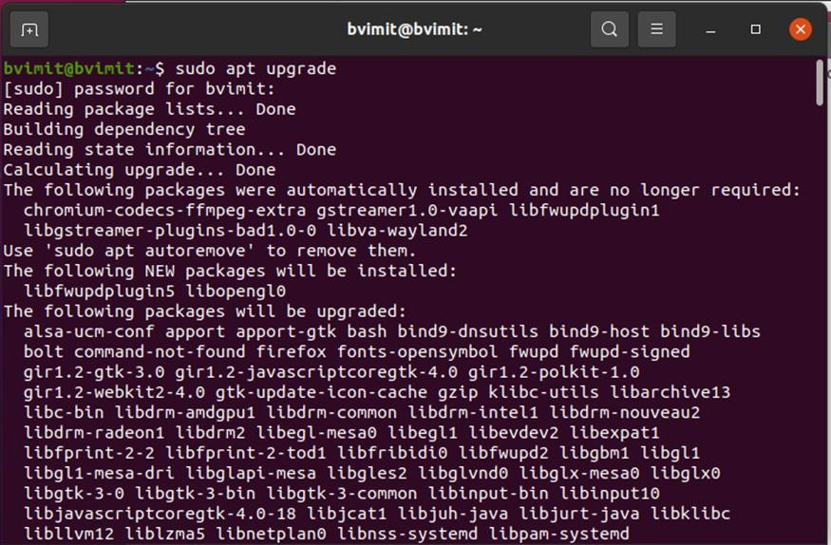

2. **sudo apt update**

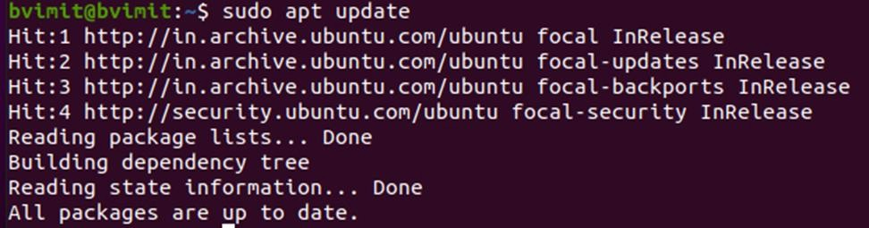

3. Minimal requirements for C++ users

**sudo apt-get install g++ python3**

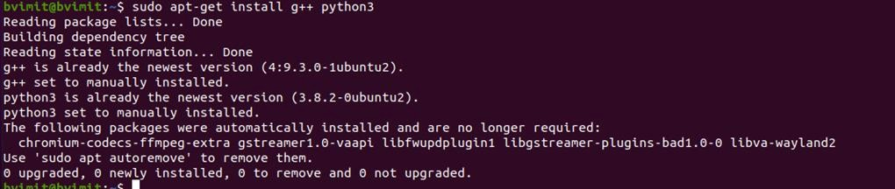

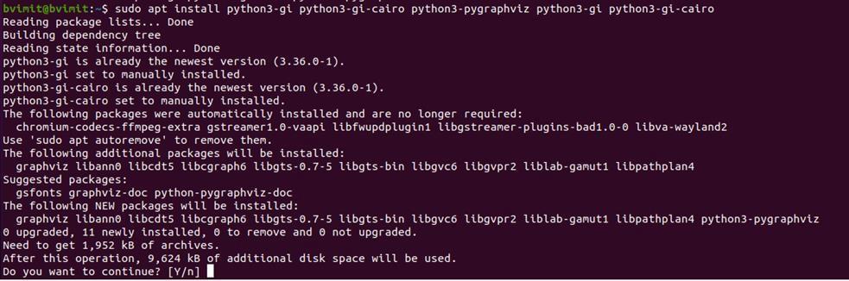

4. Minimal requirements for Python API users

**sudo apt-get install g++ python3 python3-dev pkg-config sqlite3**

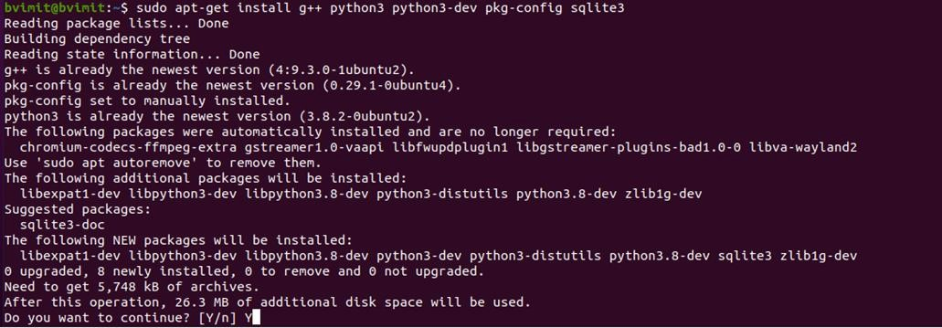

5. **Netanim animator:** qt5 development tools are needed for Netanim animator

**sudo apt-get install qt5-default mercurial**

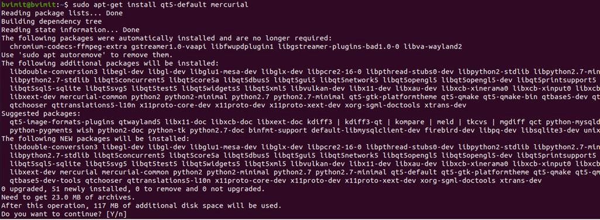

6. ns-3-pyviz visualizer

**sudo apt-get install gir1.2-goocanvas-2.0**

**sudo apt-get install python3-gi python3-gi-cairo python3-pygraphviz python3-gi python3-gi- cairo**

**sudo apt-get install python3-pygraphviz gir1.2-gtk-3.0 ipython3 ipython3**

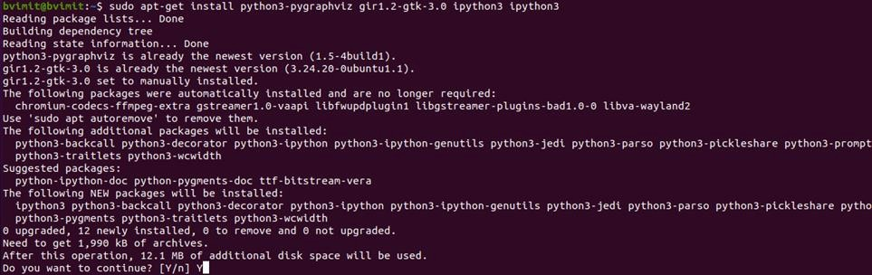

7. Debugging:

**sudo apt-get install gdb valgrind**

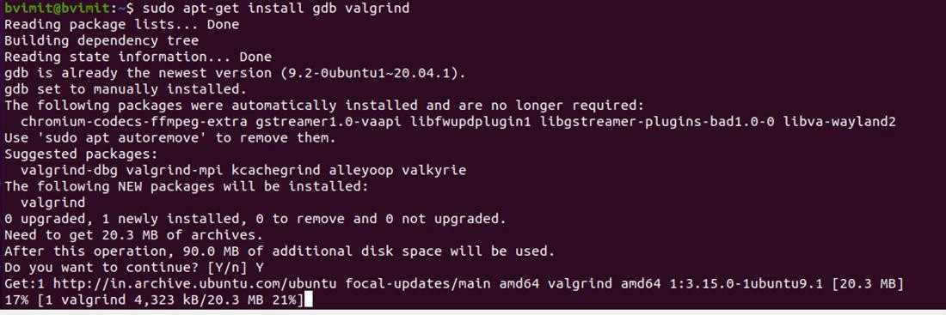

8. Doxygen and related inline documentation:

**sudo apt-get install doxygen graphviz imagemagick**

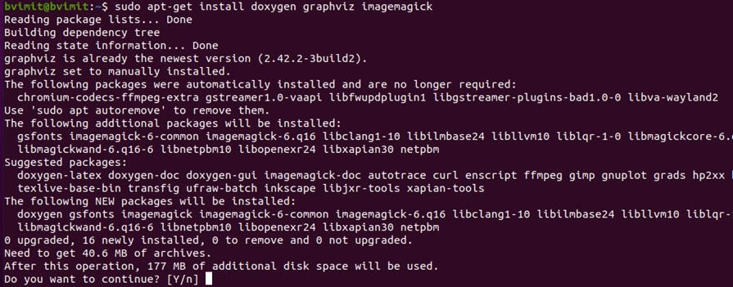

**sudo apt-get install texlive texlive-extra-utils texlive-latex-extra texlive-font-utils dvipng latexmk**

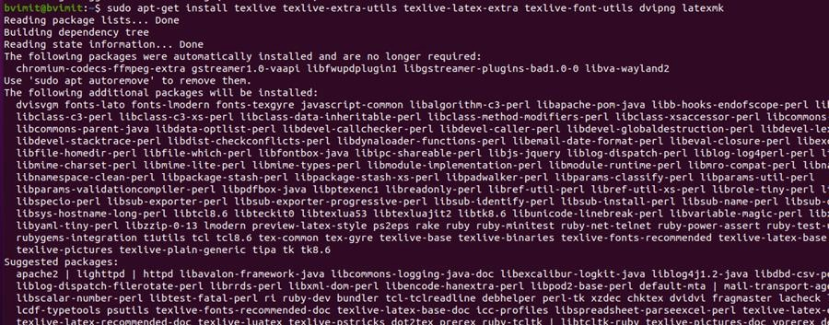

9. The ns-3 manual and tutorial are written in reStructuredText for Sphinx (doc/tutorial, doc/manual, doc/models), and figures typically in dia (also needs the texlive packages above):

**sudo apt-get install python3-sphinx dia**

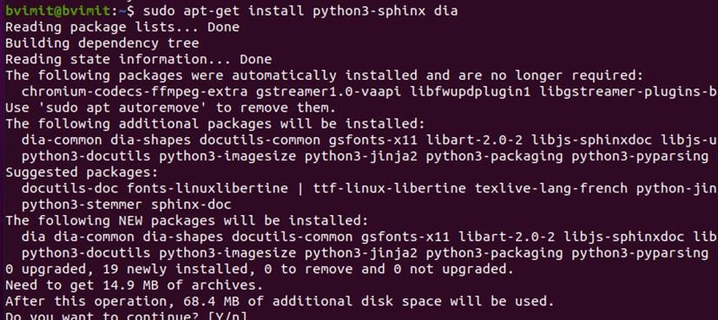

10. To read pcap packet traces:

**sudo apt-get install tcpdump**

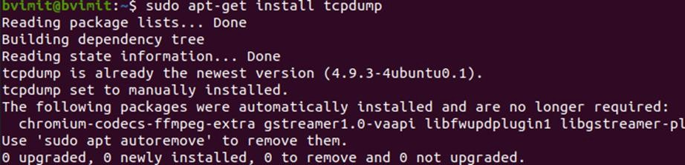

Support for generating modified python bindings:

**sudo apt-get install cmake libc6-dev libc6-dev-i386 libclang- 6.0-dev llvm-6.0-dev automake python3-pip**

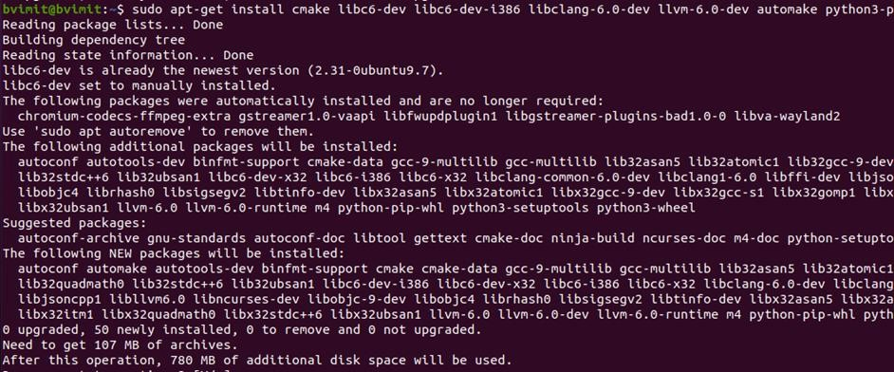

**python3 -m pip install --user cxxfilt**

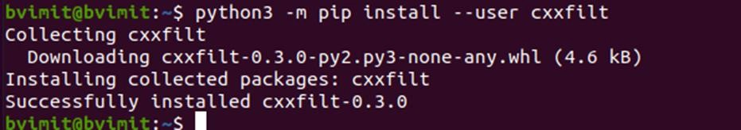

After installing the required packages, create a folder named workspace in the home directory and then put the NS3 tar package into the workspace.

Go to terminal and input these commands consecutively after each command finishes executing: ( go to the folder workspace where ns3 is installed)

cd workspace

tarxjf<name of NS3 downloaded file name> (to unzip the file) otherwise you can unzip by right clicking and selecting explore option)

cd<name of extracted NS3>

// go to the ns3allinone folder

bvimit@bvimit:~/workspace/ns-allinone-3.32$

/build.py --enable-examples –enable-tests

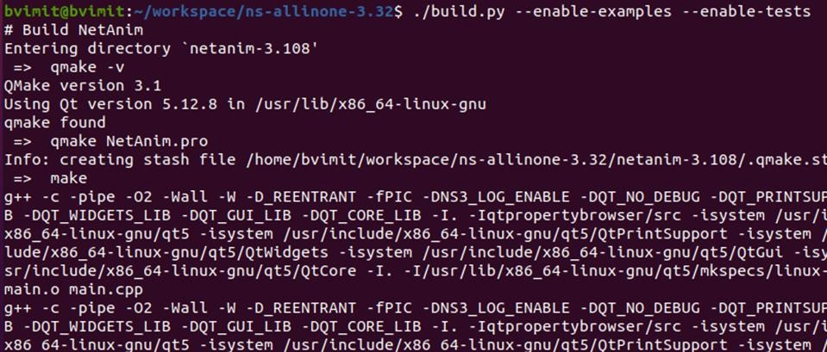

(It takes time)

Test the NS3 build and installation success by running test.py in the ns directory using the following commands:

cd ns-<version number> //go to the folder // ns3 folder in ns3allinone bvimit@bvimit:~/workspace/ns-allinone-3.32/ns-3.32$

then type,

./test.py

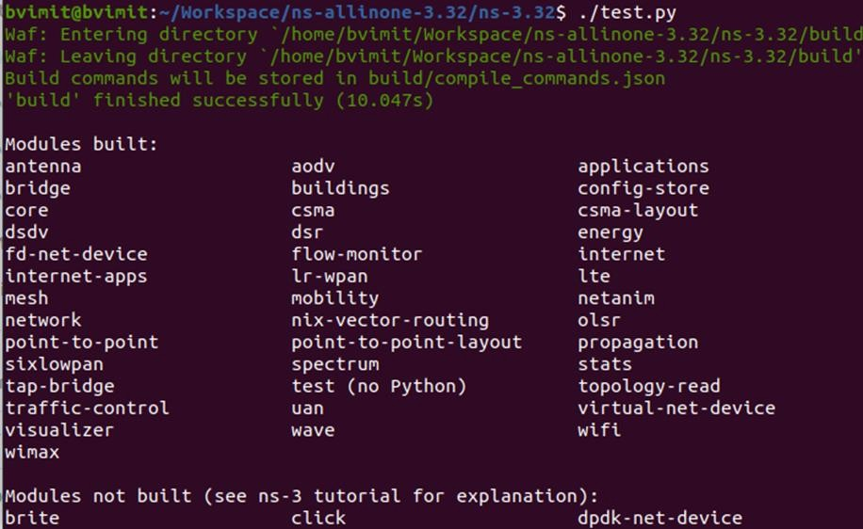

$] **./waf --run hello-simulator**

This will display "Hello Simulator" Which indicates that ns3 is installed successfully.

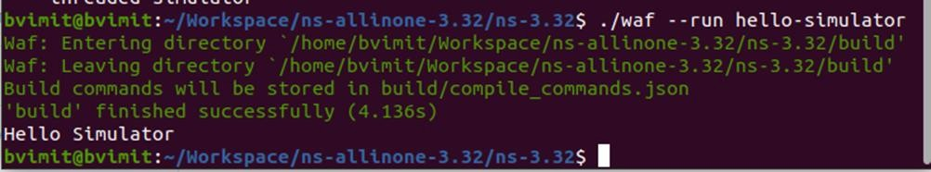

**Practical 2**

**Installation of NetAnim**

Step1: Open terminal and type sudo apt upgrade .

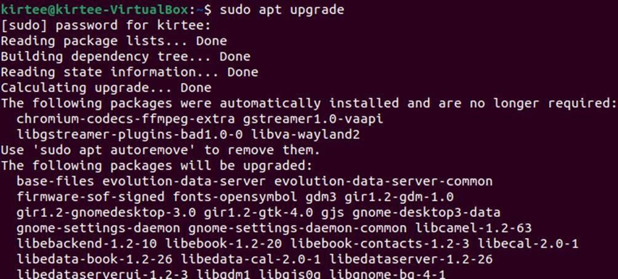

Step 2: sudo apt update

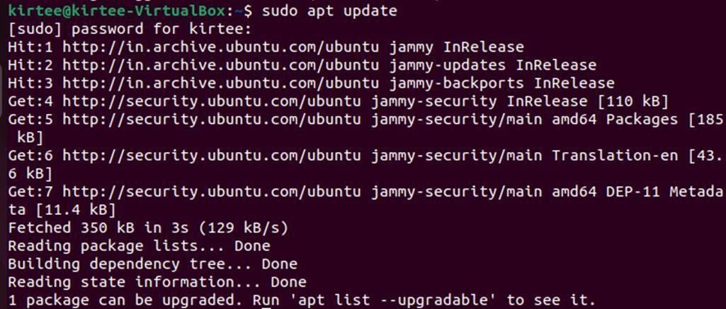

Step 3: sudo ./waf configure

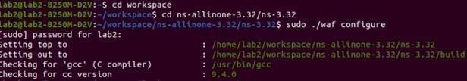

Step 4: sudo ./waf build

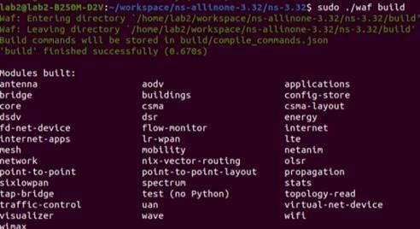

Step 5: cd netanim-3.108 & ls

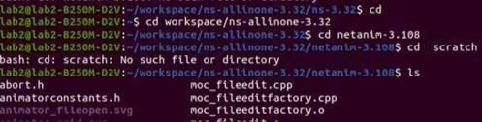

Step 6: ./NetAnim



Successfully the NetAnim will be installed

Step 7:- ./NetAnim



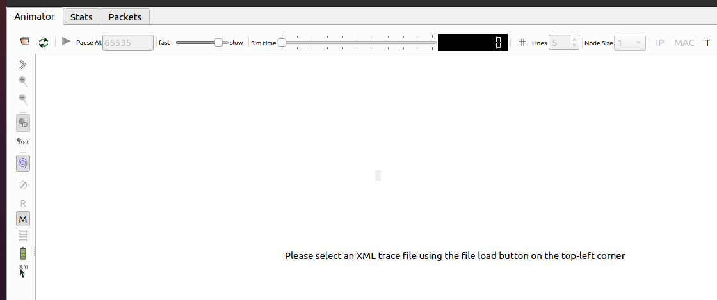

Open the folder->ns-3.32->first.xml.

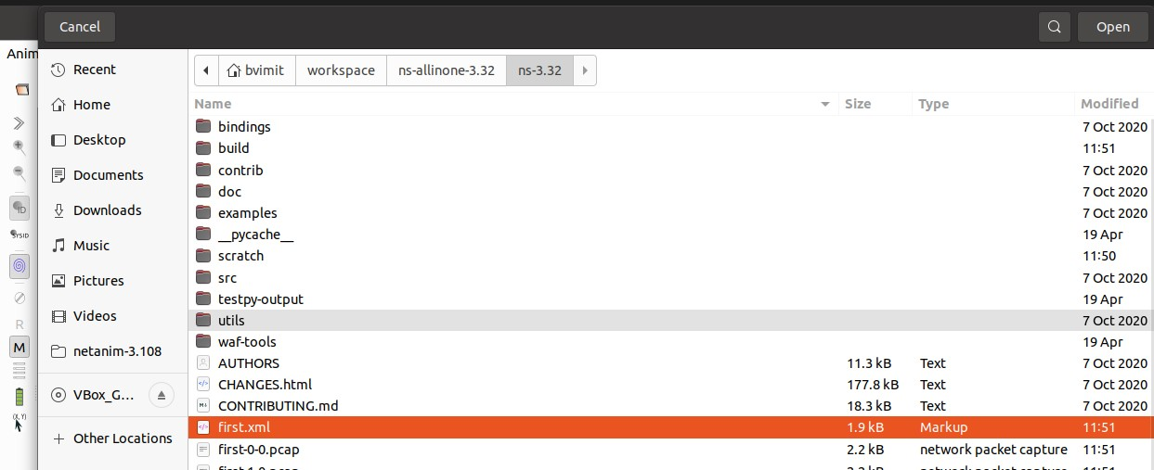

Then Start the simulation

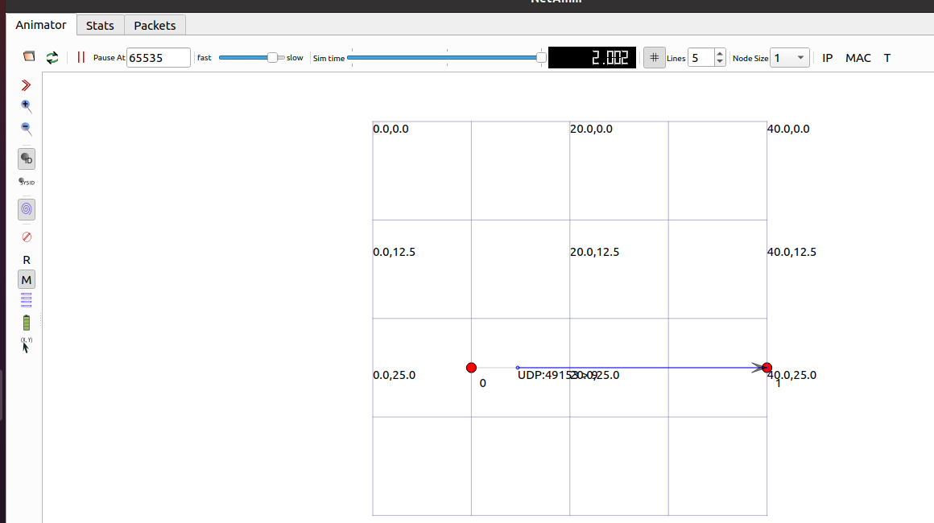

**Practical 3**

**Installation of WireShark**

**A] For Linux:**

Open Terminal and type the command

**sudo apt install wireshark**

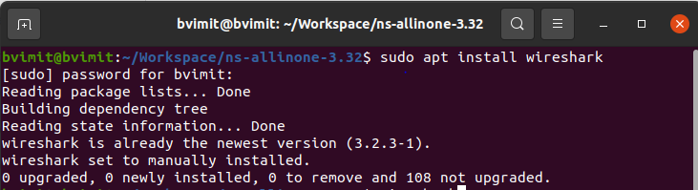

Then again type **wireshark** in terminal then directly it will open the wireshark

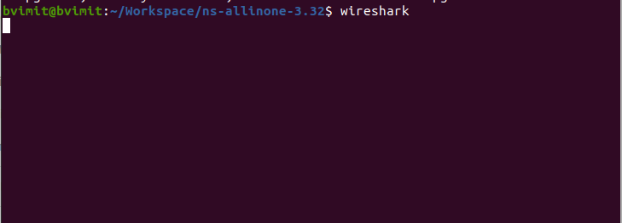

When wireshark open then **file -> open-> Go to ns-3.2** and **open the first-0-0.pcap folder**

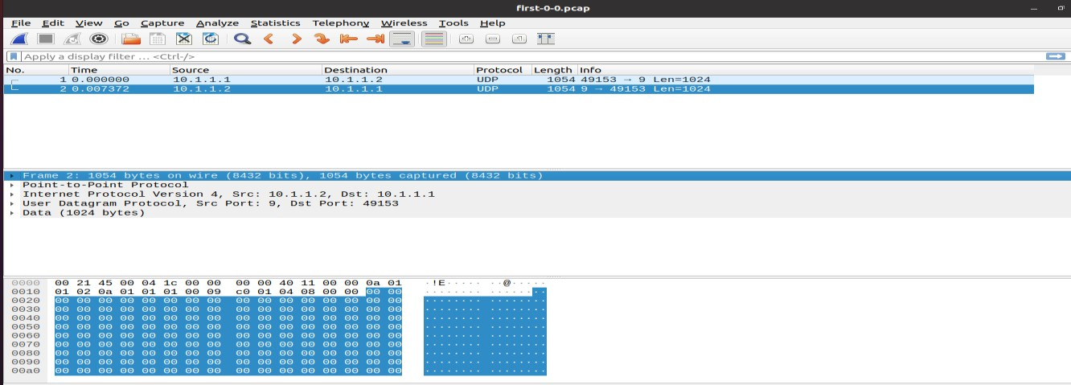

**B] For Windows:**

Step 1: Download the latest version of Wireshark on your windows operating system.

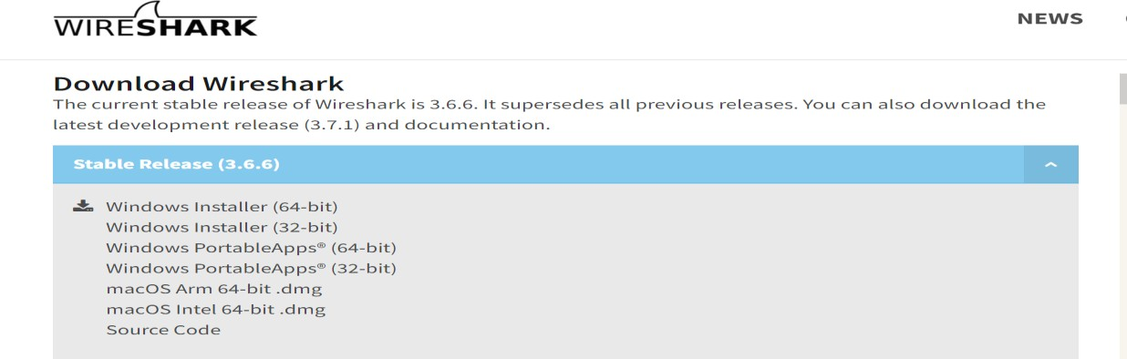

Step 2: Install Wireshark on your system.

|  |  |
| --- | --- |
|  |  |

|  |  |
| --- | --- |
|  |  |
|  |  |

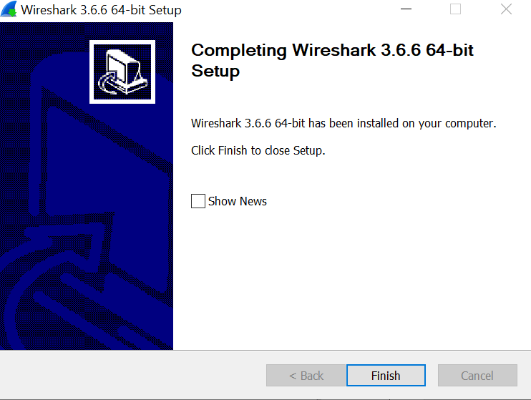

Wireshark is successfully installed on your window system.

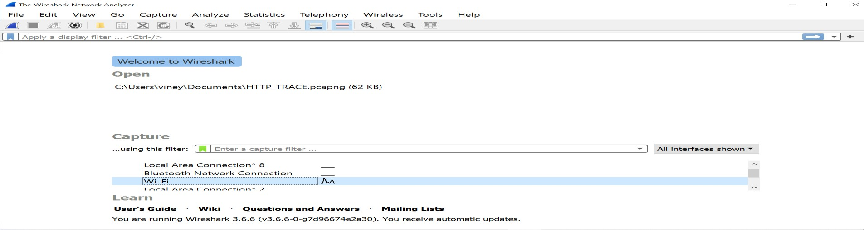

**Practical 4**

**Program to simulate traffic between two nodes**

Using Visualization first.cc

Code:-

//pre defined modules

#include "ns3/core-module.h"

#include "ns3/network-module.h"

#include "ns3/internet-module.h"

#include "ns3/point-to-point-module.h"

#include "ns3/applications-module.h"

// Default Network Topology

//

// 10.1.1.0

// n0 n1

// point-to-point

//

//The ns-3 project is implemented in a C++ namespace called ns3. This groups all ns -3-related declarations in a scope outside the global namespace, which will help with integration with other code.

using namespace ns3;

//Enable the log for this program.This line declares a logging component called FirstScriptExample that allows you to enable and disable console message logging by reference to the name.

NS_LOG_COMPONENT_DEFINE ("FirstScriptExample");

//It is just the declaration of the main function of your program (script).

int main (int argc, char *argv[])

{

//This command is used to read and parse command line argument.

CommandLine cmd ( FILE );

cmd.Parse (argc, argv); Time::SetResolution (Time::NS);

//These two lines of the script are used to enable two logging components that are built into the Echo Client and Echo Server applications:

LogComponentEnable ("UdpEchoClientApplication", LOG_LEVEL_INFO);

LogComponentEnable ("UdpEchoServerApplication", LOG_LEVEL_INFO);

//The NodeContainer topology helper provides a convenient way to create, manage and access any Node objects that we create in order to run a simulation. The first line above just declares a NodeContainer which we call nodes. The second line calls the Create method on the nodes object and asks the container to create two nodes

NodeContainer nodes; nodes.Create (2);

// It instantiates a PointToPointHelper object on the stack.

PointToPointHelper pointToPoint;

//It tells the PointToPointHelper object to use the value “5Mbps” (five megabits per second) as the “DataRate” when it creates a PointToPointNetDevice object.

pointToPoint.SetDeviceAttribute ("DataRate", StringValue ("5Mbps"));

//It tells the PointToPointHelper to use the value “2ms” (two milliseconds) as the value of the transmission delay of every point to point channel it subsequently creates.

pointToPoint.SetChannelAttribute ("Delay", StringValue ("2ms"));

// This line declares the device container object. NetDeviceContainer devices;

//The Install method of the PointToPointHelper takes a NodeContainer as a parameter. Internally, a NetDeviceContainer is created.

devices = pointToPoint.Install (nodes);

//The InternetStackHelper is a topology helper that is to internet stacks what the PointToPointHelper is to point-to-point net devices. The Install method takes a NodeContainer as a parameter. When it is executed, it will install an Internet Stack (TCP, UDP, IP, etc.) on each of the nodes in the node container.

InternetStackHelper stack; stack.Install (nodes);

//It declares an address helper object and tell it that it should begin allocating IP addresses from the network 10.1.1.0 using the mask 255.255.255.0 to define the allocatable bits. By default the addresses allocated will start at one and increase monotonically, so the first address allocated from this base will be 10.1.1.1, followed by 10.1.1.2, etc.

Ipv4AddressHelper address;

address.SetBase ("10.1.1.0", "255.255.255.0");

//It performs the actual address assignment.

Ipv4InterfaceContainer interfaces = address.Assign (devices);

//Set up a UDP echo server application on one of the nodes we have previously created.

//Declares the UdpEchoServerHelper at port 9

UdpEchoServerHelper echoServer (9);

//This method actually causes the underlying echo server application to be instantiated and attached to a node.

ApplicationContainer serverApps = echoServer.Install (nodes.Get (1));

//Define the start time of server. serverApps.Start (Seconds (1.0));

//Define the stop time of server. serverApps.Stop (Seconds (10.0));

//Set up a UDP echo client application on one of the nodes we have previously created.

The first two Attributes are set during construction of the UdpEchoClientHelper. We pass parameters that are used (internally to the helper) to set the “RemoteAddress” and “RemotePort” Attributes.

UdpEchoClientHelper echoClient (interfaces.GetAddress (1), 9);

//The “MaxPackets” Attribute tells the client the maximum number of packets we allow it to send during the simulation.

echoClient.SetAttribute ("MaxPackets", UintegerValue (1));

//The “Interval” Attribute tells the client how long to wait between packets, and the “PacketSize” Attribute tells the client how large its packet payloads should be. With this particular combination of Attributes, we are telling the client to send one 1024-byte packet.

echoClient.SetAttribute ("Interval", TimeValue (Seconds (1.0)));

echoClient.SetAttribute ("PacketSize", UintegerValue (1024));

//This method actually causes the underlying echo client application to be instantiated.

ApplicationContainer clientApps = echoClient.Install (nodes.Get (0));

//This define the start time. clientApps.Start (Seconds (2.0));

//This define the stop time. clientApps.Stop (Seconds (10.0));

//run the simulation.

Simulator::Run ();

//destroy all of the objects that were created.

Simulator::Destroy ();

return 0;

}

(Put the first.cc program in scratch folder)

1. ./waf --run scratch/first

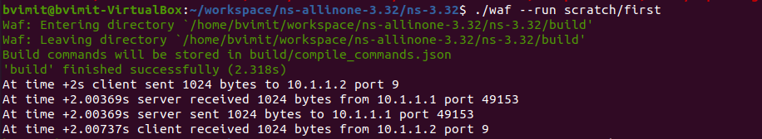

2. ./waf --run scratch/first –vis

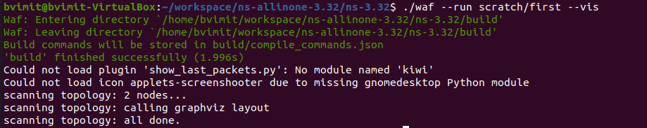

**Output:**

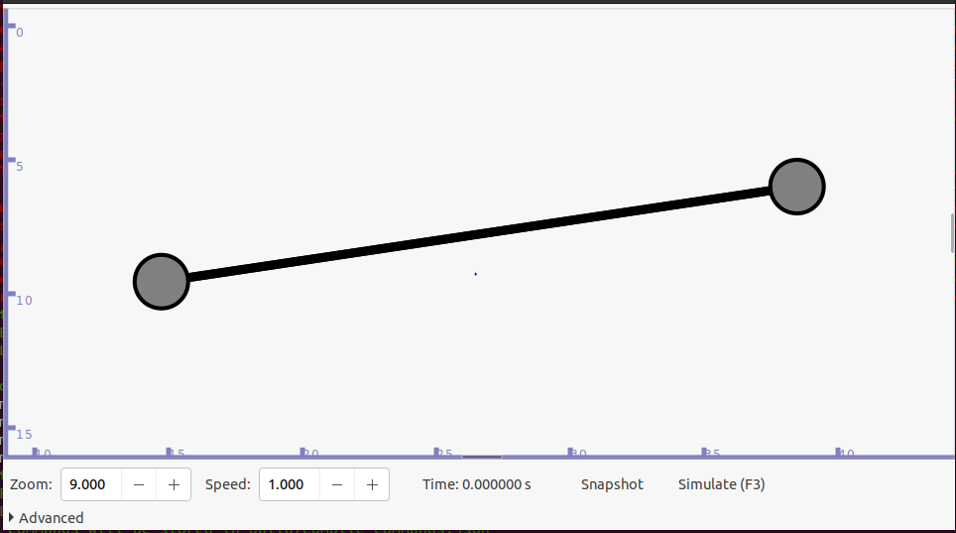

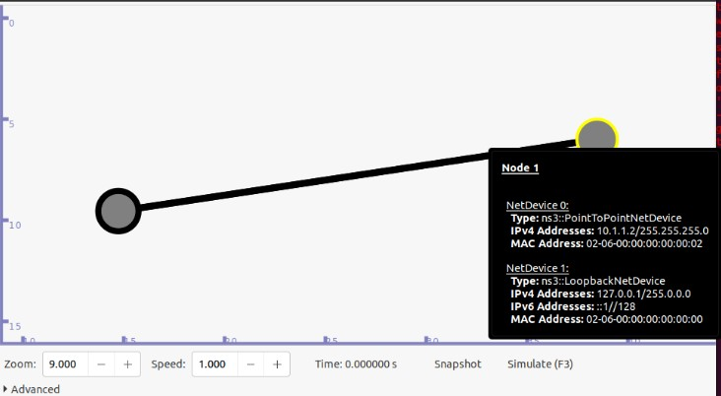

**Practical 5**

**Animate traffic between two nodes in NetAnim and analyse pcap files using wireshark**

**File Name:** animation.cc

**Code:**

#include "ns3/core-module.h"

#include "ns3/network-module.h"

#include "ns3/internet-module.h"

#include "ns3/point-to-point-module.h"

#include "ns3/applications-module.h"

//netanimation

#include "ns3/netanim-module.h"

#include "ns3/mobility-module.h"

using namespace ns3;

NS_LOG_COMPONENT_DEFINE ("FirstScriptExample");

Int main (int argc, char *argv[])

{

CommandLine cmd ( FILE );

cmd.Parse (argc, argv);

LogComponentEnable ("UdpEchoClientApplication", LOG_LEVEL_INFO);

LogComponentEnable ("UdpEchoServerApplication", LOG_LEVEL_INFO);

NodeContainer nodes;

nodes.Create (2);

PointToPointHelper pointToPoint;

pointToPoint.SetDeviceAttribute ("DataRate", StringValue ("5Mbps")); pointToPoint.SetChannelAttribute ("Delay", StringValue ("2ms"));

NetDeviceContainer devices;

devices= pointToPoint.Install (nodes);

InternetStackHelper stack; stack.Install (nodes);

Ipv4AddressHelper address;

address.SetBase ("10.1.1.0", "255.255.255.0");

Ipv4InterfaceContainer interfaces = address.Assign (devices);

UdpEchoServerHelper echoServer (9);

ApplicationContainer serverApps = echoServer.Install (nodes.Get (1)); serverApps.Start(Seconds(1.0));

serverApps.Stop (Seconds (10.0));

UdpEchoClientHelper echoClient (interfaces.GetAddress (1), 9);

echoClient.SetAttribute ("MaxPackets", UintegerValue (1));

echoClient.SetAttribute ("Interval", TimeValue (Seconds (1.0)));

echoClient.SetAttribute ("PacketSize", UintegerValue (1024));

ApplicationContainer clientApps = echoClient.Install (nodes.Get (0));

clientApps.Start (Seconds (2.0));

clientApps.Stop (Seconds (10.0));

MobilityHelper mobility;

mobility.SetMobilityModel("ns3::ConstantPositionMobilityModel");

mobility.Install(nodes);

AnimationInterface anim("first.xml");

AnimationInterface::SetConstantPosition (nodes.Get(0), 10, 25);

AnimationInterface::SetConstantPosition (nodes.Get(1), 40, 25);

anim.EnablePacketMetadata(true);

pointToPoint.EnablePcapAll("first");

Simulator::Run ();

Simulator::Destroy ();

return 0;

}

**Output:**

1. ./waf --run scratch/animation

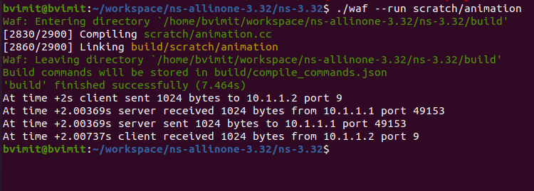

2. ls *.xml



The first.xml file is created in the ns-3.32 folder

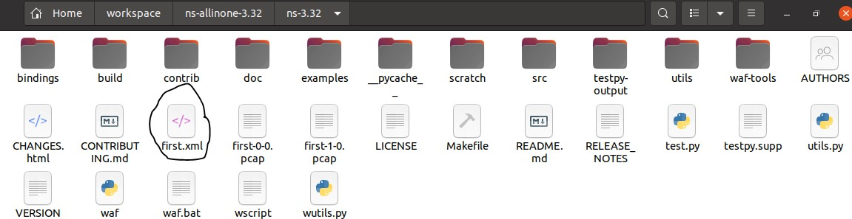

3. ./NetAnim



Open folder ns-3.32 -> first.xml



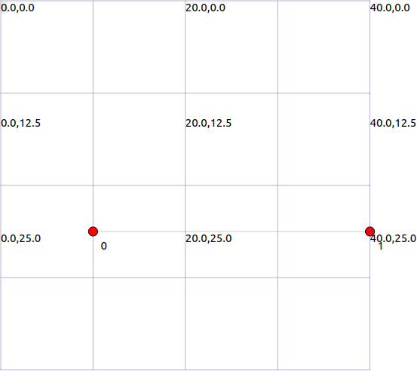



**Practical 6**

**Program to simulate bus topology**

**File Name:** Buss.cc

**Code:**

#include "ns3/core-module.h"

#include "ns3/network-module.h"

#include "ns3/csma-module.h"

#include "ns3/internet-module.h"

#include "ns3/point-to-point-module.h"

#include "ns3/applications-module.h"

#include "ns3/ipv4-global-routing-helper.h"

//netanimations

#include "ns3/netanim-module.h"

#include "ns3/mobility-module.h"

//Default Network Topology

//

//10.1.1.0

//n0........n1

// |

// ---------------

// | | |

// n2 n3 n4

// point-to-point

//Bus Topology

using namespace ns3;

NS_LOG_COMPONENT_DEFINE("SecondScriptExample");

int

main(int argc, char *argv[])

{

bool verbose=true;

uint32_t nCsma=3;

CommandLine cmd(__FILE__);

cmd.AddValue("nCsma","Number of\"extra\"CSMA nodes/devices",nCsma);

cmd.AddValue("verbose","Tell echo application to log if true", verbose);

cmd.Parse(argc, argv);

if(verbose)

{

//Time::SetResolution (Time::NS);

LogComponentEnable ("UdpEchoClientApplication", LOG_LEVEL_INFO);

LogComponentEnable ("UdpEchoServerApplication", LOG_LEVEL_INFO);

}

nCsma=nCsma==0?1:nCsma;

NodeContainer p2pNodes;

p2pNodes.Create(2);

NodeContainer csmaNodes;

csmaNodes.Add(p2pNodes.Get(1));

csmaNodes.Create(nCsma);

PointToPointHelper pointToPoint;

pointToPoint.SetDeviceAttribute ("DataRate", StringValue("5Mbps"));

pointToPoint.SetChannelAttribute ("Delay", StringValue("2ms"));

NetDeviceContainer p2pDevices;

p2pDevices =pointToPoint.Install(p2pNodes);

CsmaHelper csma;

csma.SetChannelAttribute("DataRate", StringValue("100Mbps"));

csma.SetChannelAttribute("Delay", TimeValue(NanoSeconds(6560)));

NetDeviceContainer csmaDevices;

csmaDevices =csma.Install(csmaNodes);

InternetStackHelper stack;

stack.Install (p2pNodes.Get(0));

stack.Install(csmaNodes);

Ipv4AddressHelper address;

address.SetBase("10.1.1.0", "255.255.255.0");

Ipv4InterfaceContainer p2pInterfaces;

p2pInterfaces=address.Assign(p2pDevices);

address.SetBase("10.1.2.0", "255.255.255.0");

Ipv4InterfaceContainer csmaInterfaces;

csmaInterfaces=address.Assign(csmaDevices);

UdpEchoServerHelper echoServer(9);

ApplicationContainer serverApps =echoServer.Install (csmaNodes.Get(nCsma));

serverApps.Start (Seconds(1.0));

serverApps.Stop(Seconds(10.0));

UdpEchoClientHelper echoClient (csmaInterfaces.GetAddress(nCsma), 9);

echoClient.SetAttribute ("MaxPackets", UintegerValue(1));

echoClient.SetAttribute ("Interval", TimeValue(Seconds(1.0)));

echoClient.SetAttribute ("PacketSize", UintegerValue(1024));

ApplicationContainer clientApps =echoClient.Install (p2pNodes.Get(0));

clientApps.Start (Seconds(2.0));

clientApps.Stop(Seconds(10.0));

Ipv4GlobalRoutingHelper::PopulateRoutingTables();

pointToPoint.EnablePcapAll("second");

csma.EnablePcap("second", csmaDevices.Get(1), true);

//for Net Anim

MobilityHelper mobility;

mobility.SetMobilityModel("ns3::ConstantPositionMobilityModel");

mobility.Install(p2pNodes);

mobility.Install(csmaNodes);

AnimationInterface anim("second111.xml");

AnimationInterface::SetConstantPosition(p2pNodes.Get(0), 10, 25);

AnimationInterface::SetConstantPosition(p2pNodes.Get(1), 40, 25);

AnimationInterface::SetConstantPosition(csmaNodes.Get(1), 10, 25);

AnimationInterface::SetConstantPosition(csmaNodes.Get(2), 10, 25);

AnimationInterface::SetConstantPosition(csmaNodes.Get(3), 10, 25);

anim.EnablePacketMetadata(true);

Simulator::Run();

Simulator::Destroy();

return 0;

}

**Output:**

./waf --run scratch/Buss

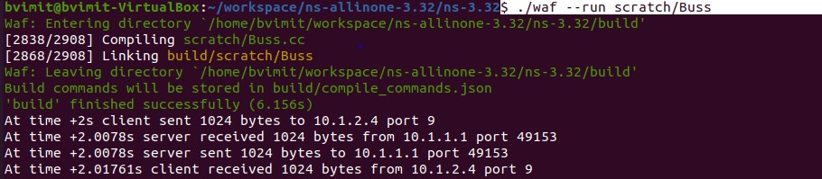

./waf --run scratch/Buss --vis

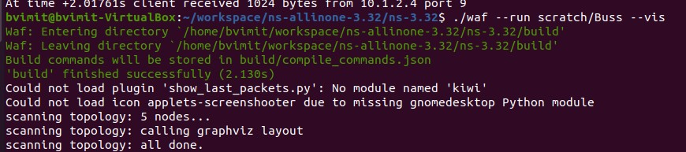

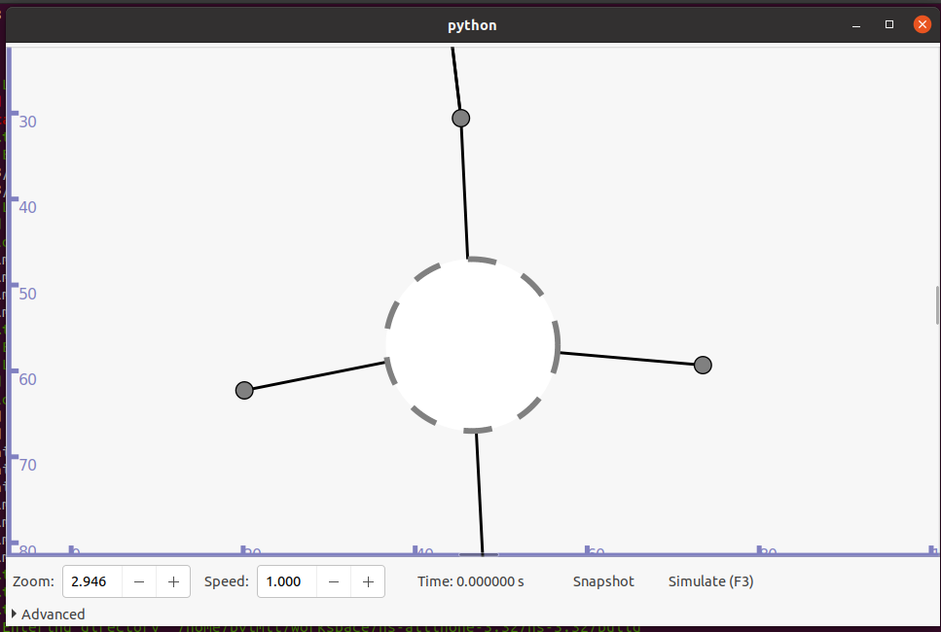

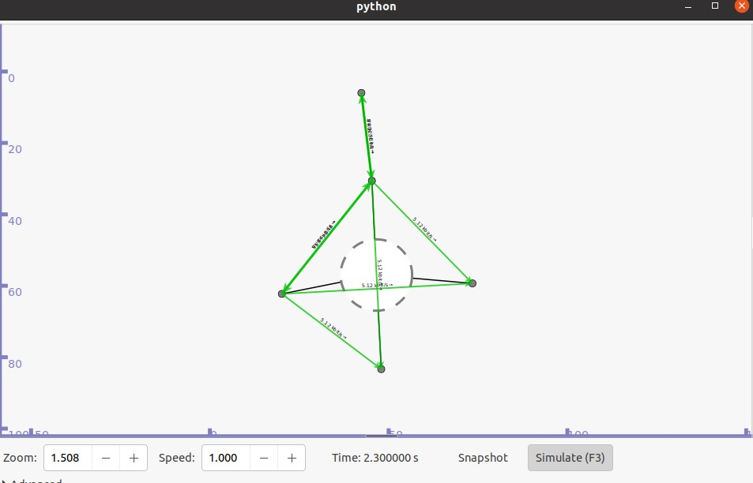

**Practical 7**

**Program to simulate bus topology Using NetAnim**

**File Name:** BussAnimate.cc

**Code:**

#include "ns3/core-module.h"

#include "ns3/network-module.h"

#include "ns3/csma-module.h"

#include "ns3/internet-module.h"

#include "ns3/point-to-point-module.h"

#include "ns3/applications-module.h"

#include "ns3/ipv4-global-routing-helper.h"

#include "ns3/netanim-module.h"

#include "ns3/mobility-module.h"

using namespace ns3;

NS_LOG_COMPONENT_DEFINE("SecondScriptExample");

Int main(int argc,char *argv[])

{

bool verbose=true;

uint32_t nCsma=3;

CommandLine cmd( FILE );

cmd.AddValue("nCsma","Number of\"extra\" CSMA nodes/devices",nCsma); cmd.AddValue("verbose","Tell echo application to log if true",verbose);

cmd.Parse(argc,argv);

if(verbose)

{

LogComponentEnable("UdpEchoClientApplication",LOG_LEVEL_INFO); LogComponentEnable("UdpEchoServerApplication",LOG_LEVEL_INFO);

}

nCsma=nCsma==0 ? 1:nCsma;

NodeContainer p2pNodes;

p2pNodes.Create(2);

NodeContainer csmaNodes;

csmaNodes.Add(p2pNodes.Get(1));

csmaNodes.Create(nCsma);

PointToPointHelper pointToPoint;

pointToPoint.SetDeviceAttribute("DataRate",StringValue ("5Mbps")); pointToPoint.SetChannelAttribute ("Delay", StringValue ("2ms"));

NetDeviceContainer p2pDevices;

p2pDevices = pointToPoint.Install (p2pNodes);

CsmaHelper csma;

csma.SetChannelAttribute("DataRate",StringValue("100Mbps")); csma.SetChannelAttribute("Delay",TimeValue(NanoSeconds(6560)));

NetDeviceContainer csmaDevices;

csmaDevices=csma.Install(csmaNodes); I

nternetStackHelper stack;

stack.Install(p2pNodes.Get(0));

stack.Install(csmaNodes);

Ipv4AddressHelper address;

address.SetBase("10.1.1.0","255.255.255.0");

Ipv4InterfaceContainer p2pInterfaces;

p2pInterfaces=address.Assign(p2pDevices);

address.SetBase ("10.1.2.0", "255.255.255.0");

Ipv4InterfaceContainer csmaInterfaces;

csmaInterfaces = address.Assign (csmaDevices);

UdpEchoServerHelper echoServer(9);

ApplicationContainer serverApps = echoServer.Install (csmaNodes.Get (nCsma));

serverApps.Start (Seconds (1.0));

serverApps.Stop (Seconds (10.0));

UdpEchoClientHelper echoClient (csmaInterfaces.GetAddress(nCsma),9); echoClient.SetAttribute("MaxPackets",UintegerValue(1)); echoClient.SetAttribute("Interval",TimeValue(Seconds(1.0))); echoClient.SetAttribute("PacketSize",UintegerValue(1024));

ApplicationContainer clientApps=echoClient.Install(p2pNodes.Get(0));

clientApps.Start (Seconds (2.0));

clientApps.Stop (Seconds (10.0));

Ipv4GlobalRoutingHelper::PopulateRoutingTables();

pointToPoint.EnablePcapAll("second");

csma.EnablePcap("second",csmaDevices.Get(1),true);

MobilityHelper mobility;

mobility.SetMobilityModel("ns3::ConstantPositionMobilityModel");

mobility.Install(csmaNodes);

mobility.Install(p2pNodes);

AnimationInterface anim("second.xml");

anim.SetConstantPosition(p2pNodes.Get(0), 10, 25);

anim.SetConstantPosition(p2pNodes.Get(1), 20, 25);

anim.SetConstantPosition(csmaNodes.Get(1), 40, 25);

anim.SetConstantPosition(csmaNodes.Get(2), 50, 25);

anim.SetConstantPosition(csmaNodes.Get(3), 60, 25);

anim.EnablePacketMetadata(true);

Simulator::Run();

Simulator::Destroy();

return 0;

Simulator::Run ();

Simulator::Destroy ();

return 0;

}

**Output:**

./waf --run scratch/BussAnimate

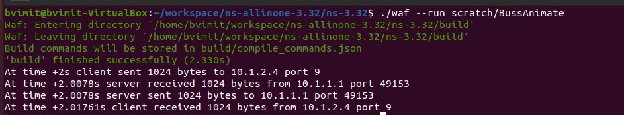

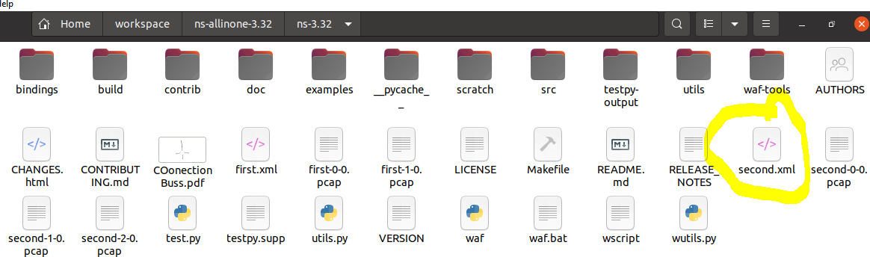

./NetAnim



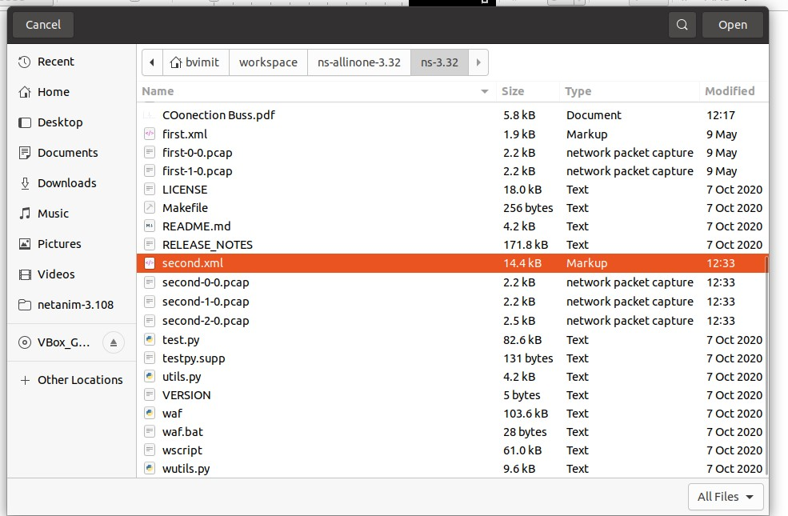

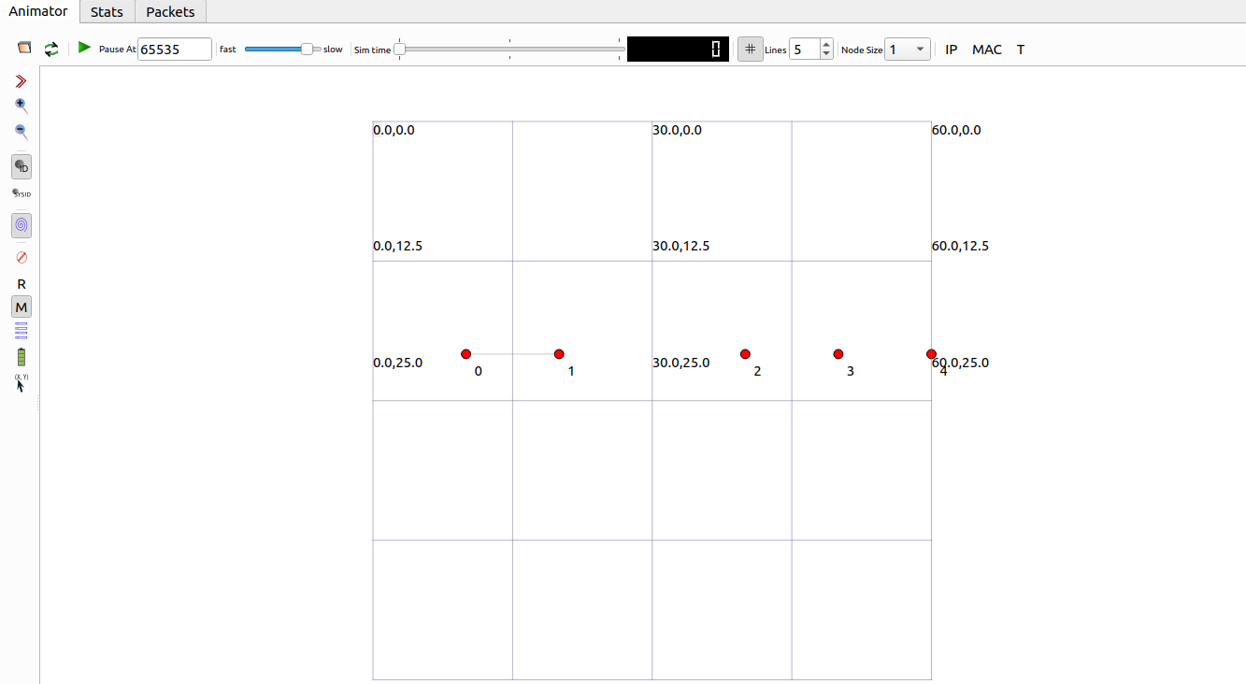

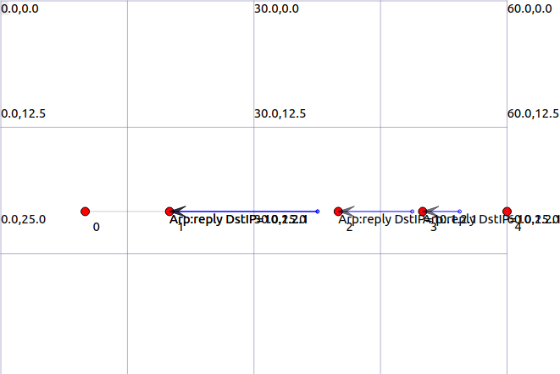

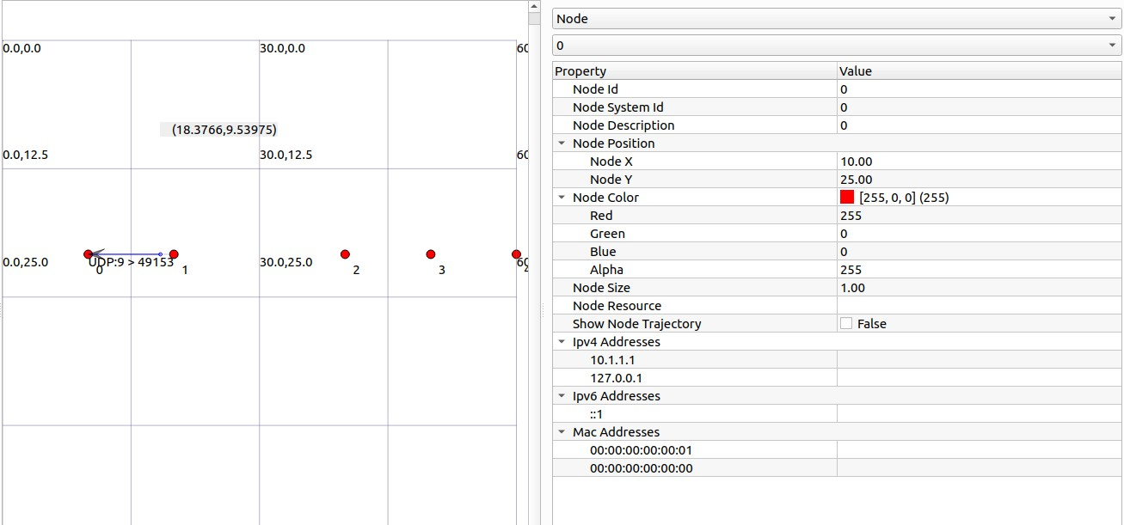

**Practical 8**

**Analyse BUS topology simulation pcap files using wireshark**

**bus_topology.cc**

**Code:**

#include "ns3/core-module.h"

#include "ns3/network-module.h"

#include "ns3/csma-module.h"

#include "ns3/internet-module.h"

#include "ns3/point-to-point-module.h"

#include "ns3/applications-module.h"

#include "ns3/ipv4-global-routing-helper.h"

#include "ns3/netanim-module.h"

#include "ns3/mobility-module.h"

using namespace ns3;

NS_LOG_COMPONENT_DEFINE("SecondScriptExample");

int main(int argc, char* argv[]){

bool verbose = true;

uint32_t nCsma = 3;

CommandLine cmd( FILE );

cmd.AddValue("mCsma","Number of \"Extra\" CSMA nodes/devices", nCsma); cmd.AddValue("verbose","Tell echo application to log if true", verbose);

cmd.Parse(argc, argv);

if(verbose)

{

LogComponentEnable("UdpEchoClientApplication", LOG_LEVEL_INFO);

LogComponentEnable("UdpEchoServerApplication", LOG_LEVEL_INFO);

}

nCsma = nCsma == 0 ? 1 : nCsma;

NodeContainer p2pNodes; p2pNodes.Create(2);

NodeContainer csmaNodes; csmaNodes.Add(p2pNodes.Get(1));

csmaNodes.Create(nCsma);

PointToPointHelper pointToPoint; pointToPoint.SetDeviceAttribute("DataRate",StringValue("5Mbps")); pointToPoint.SetChannelAttribute("Delay",StringValue("2ms"));

NetDeviceContainer p2pDevices;

p2pDevices = pointToPoint.Install(p2pNodes);

CsmaHelper csma;

csma.SetChannelAttribute("DataRate",StringValue("100Mbps")); csma.SetChannelAttribute("Delay",TimeValue(NanoSeconds(6560)));

NetDeviceContainer csmaDevices;

csmaDevices = csma.Install(csmaNodes);

InternetStackHelper stack;

stack.Install(p2pNodes.Get(0));

stack.Install(csmaNodes);

Ipv4AddressHelper address;

address.SetBase("10.1.1.0","255.555.255.0");

Ipv4InterfaceContainer p2pInterfaces;

p2pInterfaces = address.Assign(p2pDevices);

address.SetBase("10.1.2.0","255.555.255.0");

Ipv4InterfaceContainer csmaInterfaces;

csmaInterfaces = address.Assign(csmaDevices);

UdpEchoServerHelper echoServer(9);

ApplicationContainer serverApps = echoServer.Install(csmaNodes.Get(nCsma)); serverApps.Start(Seconds(1.0));

serverApps.Stop(Seconds(10.0));

UdpEchoClientHelper echoClient(csmaInterfaces.GetAddress(nCsma),9); echoClient.SetAttribute("MaxPackets", UintegerValue(1));

echoClient.SetAttribute("Interval", TimeValue(Seconds(1.0))); echoClient.SetAttribute("PacketSize", UintegerValue(1024));

ApplicationContainer clientApps = echoClient.Install(p2pNodes.Get(0)); clientApps.Start(Seconds(2.0));

clientApps.Stop(Seconds(10.0));

Ipv4GlobalRoutingHelper::PopulateRoutingTables();

MobilityHelper mobility;

mobility.SetMobilityModel("ns3::ConstantPositionMobilityModel");

mobility.Install(csmaNodes);

mobility.Install(p2pNodes);

AnimationInterface anim("second.xml");

anim.SetConstantPosition(p2pNodes.Get(0), 10, 25);

anim.SetConstantPosition(p2pNodes.Get(1), 20, 25);

anim.SetConstantPosition(csmaNodes.Get(1), 30, 15);

anim.SetConstantPosition(csmaNodes.Get(2), 40, 25);

anim.SetConstantPosition(csmaNodes.Get(3), 30, 35);

anim.EnablePacketMetadata(true);

pointToPoint.EnablePcapAll("second");

csma.EnablePcap("second", csmaDevices.Get(1), true);

Simulator::Run();

Simulator::Destroy();

return 0;

}

**Output:**

Open terminal and type below command and then type wireshark:

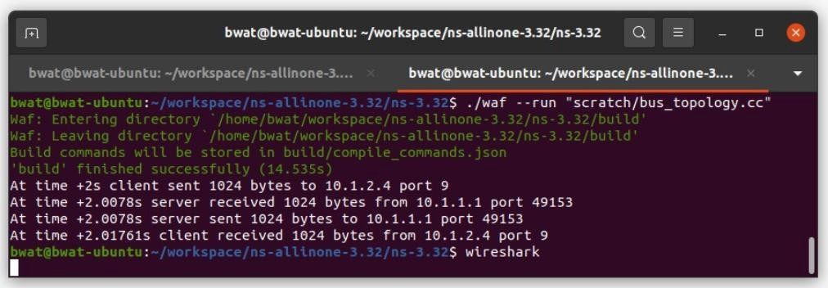

Then three pcap file as shown below will be autogenerated:

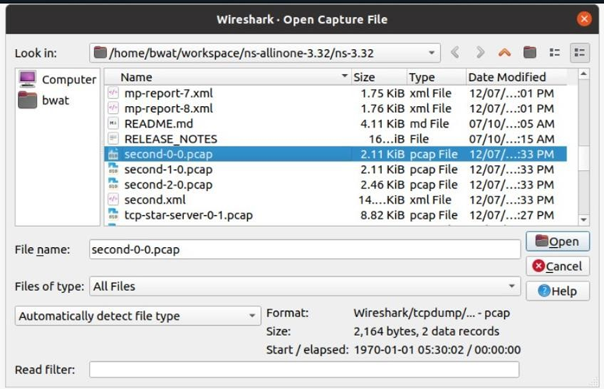

File->open-> all second pcap file->start simultion

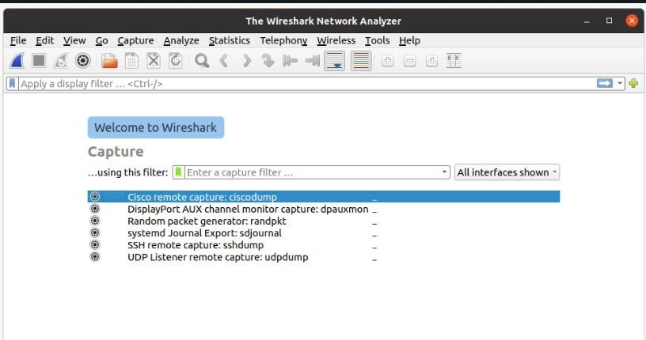

Second-0-0.pcap:

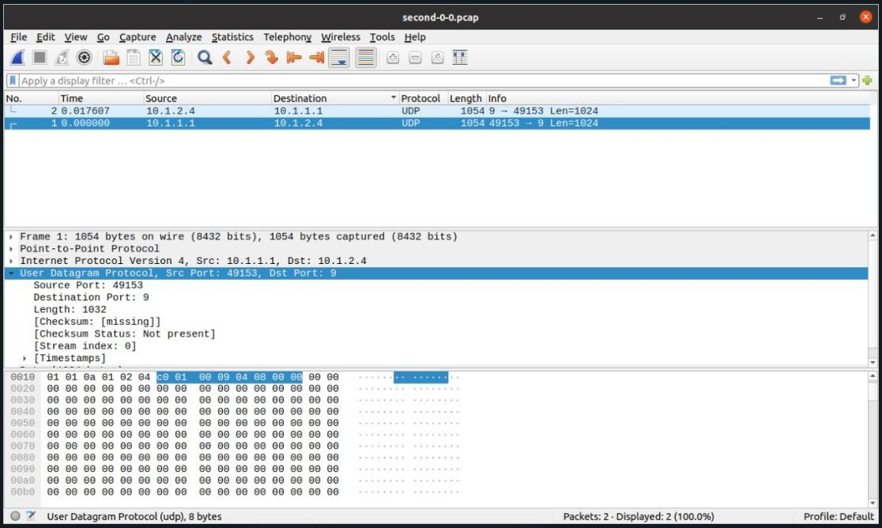

Second.1-0.pcap:

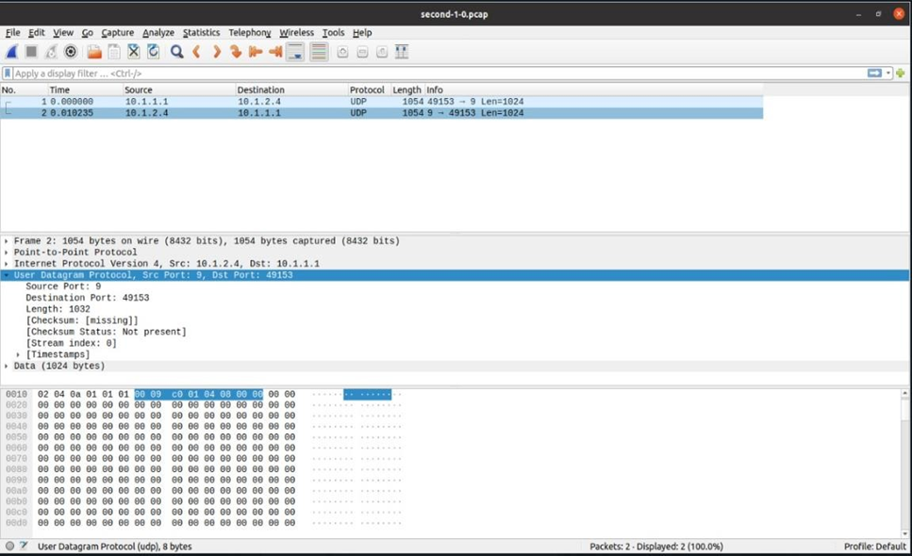

Second-2-0.pcap:

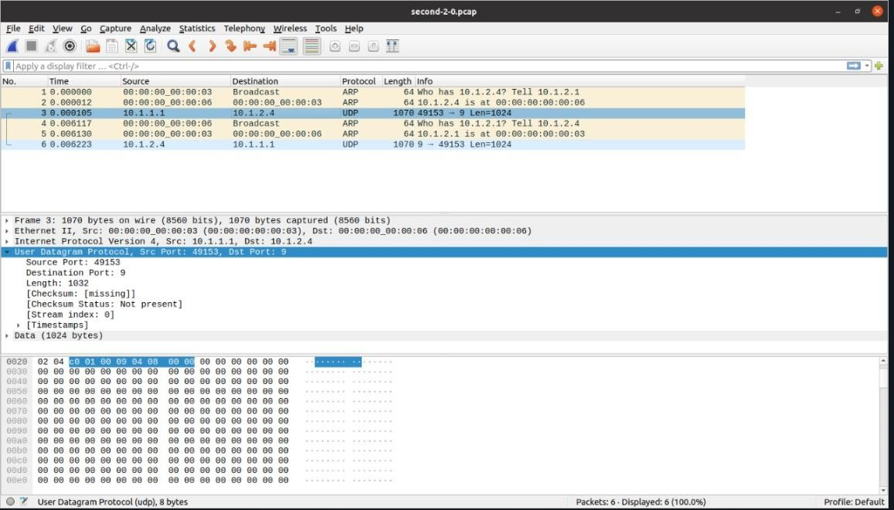

**Practical 9**

**Program to simulate star topology**

**Code:**

/* -*- Mode:C++; c-file-style:"gnu"; indent-tabs-mode:nil; -*- */

/*

* This program is free software; you can redistribute it and/or modify

* it under the terms of the GNU General Public License version 2 as

* published by the Free Software Foundation;

*

* This program is distributed in the hope that it will be useful,

* but WITHOUT ANY WARRANTY; without even the implied warranty of

* MERCHANTABILITY or FITNESS FOR A PARTICULAR PURPOSE. See the

* GNU General Public License for more details.

*

* You should have received a copy of the GNU General Public License

* along with this program; if not, write to the Free Software

* Foundation, Inc., 59 Temple Place, Suite 330, Boston, MA 02111-1307 USA

*

*/

#include "ns3/core-module.h"

#include "ns3/network-module.h"

#include "ns3/netanim-module.h"

#include "ns3/internet-module.h"

#include "ns3/point-to-point-module.h"

#include "ns3/applications-module.h"

#include "ns3/point-to-point-layout-module.h"

// Network topology (default)

//

// n2 n3 n4 .

// \ | / .

// \|/ .

// n1--- n0---n5 .

// /|\ .

// / | \ .

// n8 n7 n6 .

//

using namespace ns3;

NS_LOG_COMPONENT_DEFINE ("Star");

int

main (int argc, char *argv[])

{

//

// Set up some default values for the simulation.

//

Config::SetDefault ("ns3::OnOffApplication::PacketSize", UintegerValue (137));

// ??? try and stick 15kb/s into the data rate

Config::SetDefault ("ns3::OnOffApplication::DataRate", StringValue ("14kb/s"));

//

// Default number of nodes in the star. Overridable by command line argument.

//

uint32_t nSpokes = 8;

CommandLine cmd (__FILE__);

cmd.AddValue ("nSpokes", "Number of nodes to place in the star", nSpokes);

cmd.Parse (argc, argv);

NS_LOG_INFO ("Build star topology.");

PointToPointHelper pointToPoint;

pointToPoint.SetDeviceAttribute ("DataRate", StringValue ("5Mbps"));

pointToPoint.SetChannelAttribute ("Delay", StringValue ("2ms"));

PointToPointStarHelper star (nSpokes, pointToPoint);

NS_LOG_INFO ("Install internet stack on all nodes.");

InternetStackHelper internet;

star.InstallStack (internet);

NS_LOG_INFO ("Assign IP Addresses.");

star.AssignIpv4Addresses (Ipv4AddressHelper ("10.1.1.0", "255.255.255.0"));

NS_LOG_INFO ("Create applications.");

//

// Create a packet sink on the star "hub" to receive packets.

//

uint16_t port = 50000;

Address hubLocalAddress (InetSocketAddress (Ipv4Address::GetAny (), port));

PacketSinkHelper packetSinkHelper ("ns3::TcpSocketFactory", hubLocalAddress);

ApplicationContainer hubApp = packetSinkHelper.Install (star.GetHub ());

hubApp.Start (Seconds (1.0));

hubApp.Stop (Seconds (10.0));

//

// Create OnOff applications to send TCP to the hub, one on each spoke node.

//

OnOffHelper onOffHelper ("ns3::TcpSocketFactory", Address ());

onOffHelper.SetAttribute ("OnTime", StringValue ("ns3::ConstantRandomVariable[Constant=1]"));

onOffHelper.SetAttribute ("OffTime", StringValue ("ns3::ConstantRandomVariable[Constant=0]"));

ApplicationContainer spokeApps;

for (uint32_t i = 0; i < star.SpokeCount (); ++i)

{

AddressValue remoteAddress (InetSocketAddress (star.GetHubIpv4Address (i), port));

onOffHelper.SetAttribute ("Remote", remoteAddress);

spokeApps.Add (onOffHelper.Install (star.GetSpokeNode (i)));

}

spokeApps.Start (Seconds (1.0));

spokeApps.Stop (Seconds (10.0));

NS_LOG_INFO ("Enable static global routing.");

//

// Turn on global static routing so we can actually be routed across the star.

//

Ipv4GlobalRoutingHelper::PopulateRoutingTables ();

NS_LOG_INFO ("Enable pcap tracing.");

//

// Do pcap tracing on all point-to-point devices on all nodes.

//

pointToPoint.EnablePcapAll ("star");

NS_LOG_INFO ("Run Simulation.");

Simulator::Run ();

Simulator::Destroy ();

NS_LOG_INFO ("Done.");

return 0;

}

**Output:**

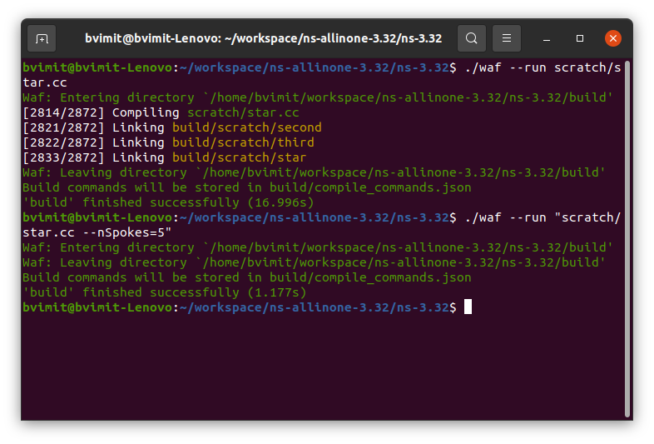

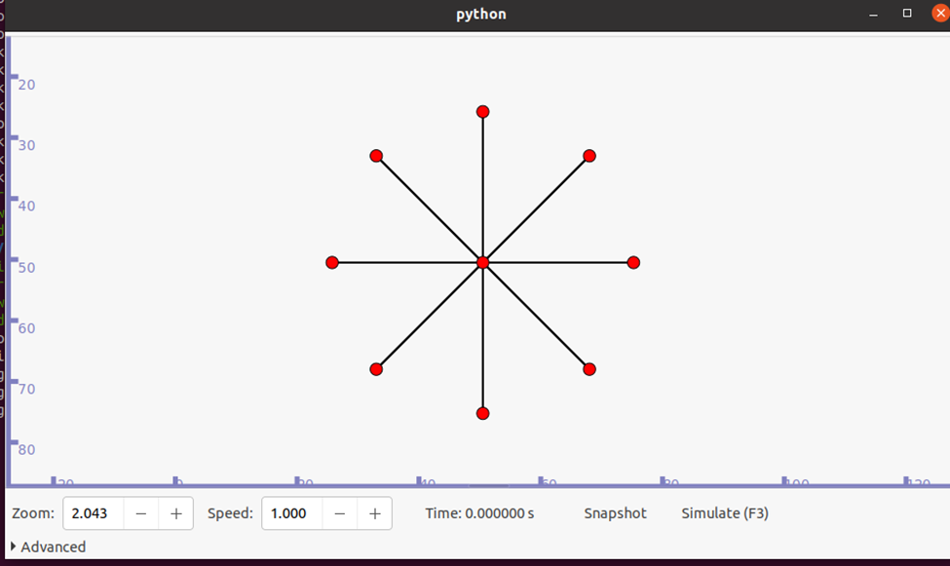

**Practical 10**

**Animate Star Topology in NetAnim**

**Code:**

#include "ns3/core-module.h"

#include "ns3/network-module.h"

#include "ns3/netanim-module.h"

#include "ns3/internet-module.h"

#include "ns3/point-to-point-module.h"

#include "ns3/applications-module.h"

#include "ns3/point-to-point-layout-module.h"

using namespace ns3;

NS_LOG_COMPONENT_DEFINE ("Star");

int main (int argc, char *argv[])

{

Config::SetDefault ("ns3::OnOffApplication::PacketSize", UintegerValue (137));

Config::SetDefault ("ns3::OnOffApplication::DataRate", StringValue ("14kb/s"));

uint32_t nSpokes = 8;

CommandLine cmd ( FILE );

cmd.AddValue ("nSpokes", "Number of nodes to place in the star", nSpokes);

cmd.Parse (argc, argv);

NS_LOG_INFO ("Build star topology.");

PointToPointHelper pointToPoint;

pointToPoint.SetDeviceAttribute ("DataRate", StringValue ("5Mbps")); pointToPoint.SetChannelAttribute ("Delay", StringValue ("2ms"));

PointToPointStarHelper star (nSpokes, pointToPoint);

NS_LOG_INFO ("Install internet stack on all nodes.");

InternetStackHelper internet;

star.InstallStack (internet);

NS_LOG_INFO ("Assign IP Addresses.");

star.AssignIpv4Addresses (Ipv4AddressHelper ("10.1.1.0", "255.255.255.0"));

NS_LOG_INFO ("Create applications.");

uint16_t port = 50000;

Address hubLocalAddress (InetSocketAddress (Ipv4Address::GetAny (), port));

PacketSinkHelper packetSinkHelper ("ns3::TcpSocketFactory", hubLocalAddress); ApplicationContainer hubApp = packetSinkHelper.Install (star.GetHub ());

hubApp.Start (Seconds (1.0));

hubApp.Stop (Seconds (10.0));

OnOffHelper onOffHelper ("ns3::TcpSocketFactory", Address ());

onOffHelper.SetAttribute ("OnTime", StringValue ("ns3::ConstantRandomVariable[Constant=1]")); onOffHelper.SetAttribute ("OffTime", StringValue ("ns3::ConstantRandomVariable[Constant=0]"));

ApplicationContainer spokeApps;

for (uint32_t i = 0; i < star.SpokeCount (); ++i)

{

AddressValue remoteAddress (InetSocketAddress (star.GetHubIpv4Address (i), port)); onOffHelper.SetAttribute ("Remote", remoteAddress);

spokeApps.Add (onOffHelper.Install (star.GetSpokeNode (i)));

}

spokeApps.Start (Seconds (1.0));

spokeApps.Stop (Seconds (10.0));

NS_LOG_INFO ("Enable static global routing.");

Ipv4GlobalRoutingHelper::PopulateRoutingTables ();

NS_LOG_INFO ("Enable pcap tracing.");

pointToPoint.EnablePcapAll ("star");

std::string animFile = "star.xml";

star.BoundingBox (1, 1, 100, 100);

AnimationInterface anim (animFile);

NS_LOG_INFO ("Run Simulation.");

Simulator::Run ();

Simulator::Destroy ();

NS_LOG_INFO ("Done.");

return 0;

}

**Output:**

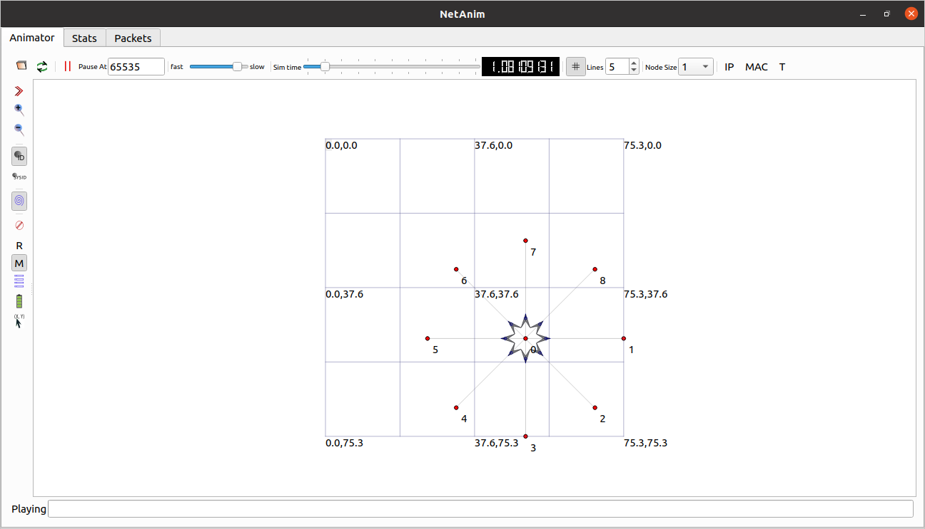

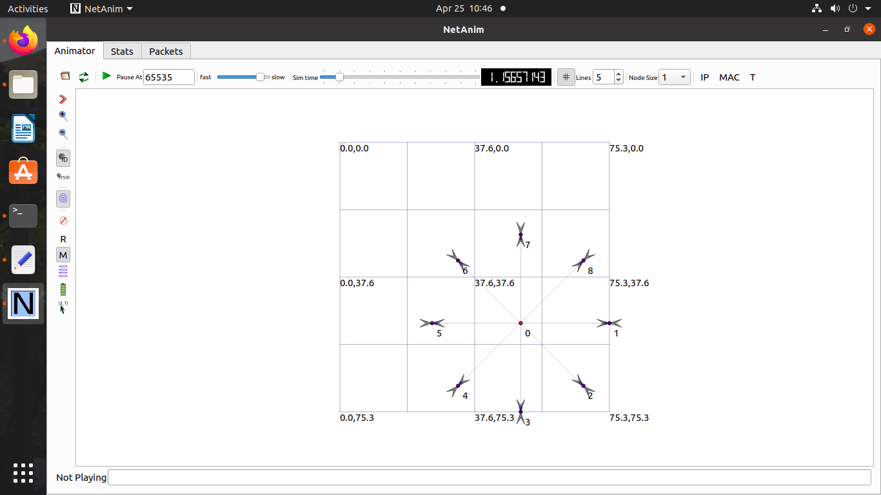

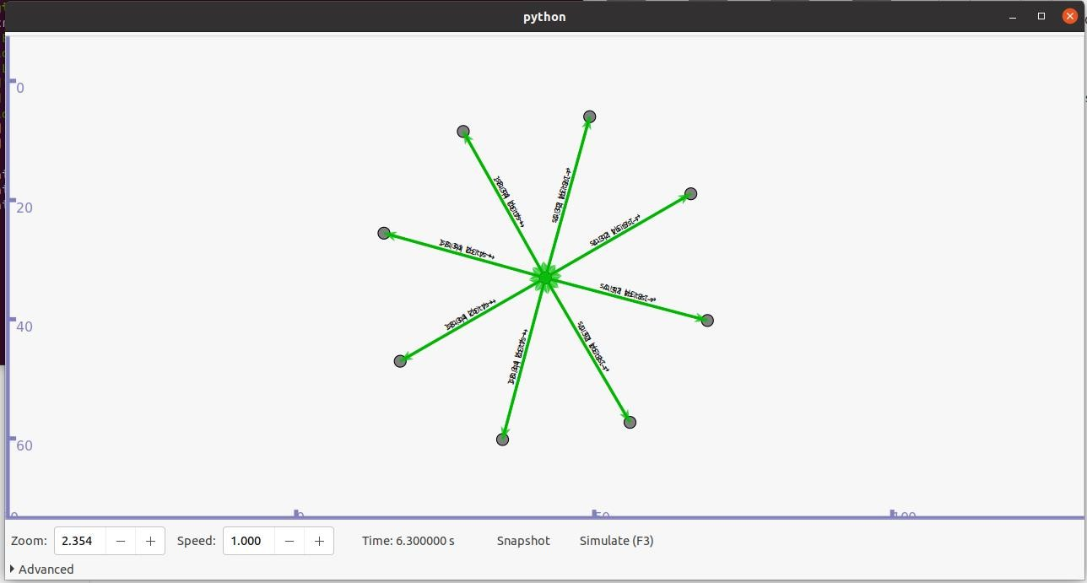

**Practical 11**

**Program to simulate Mesh topology**

**Code:**

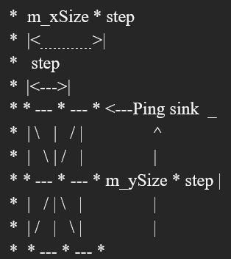

#include <iostream>

#include <sstream>

#include <fstream>

#include "ns3/core-module.h"

#include "ns3/internet-module.h"

#include "ns3/network-module.h"

#include "ns3/applications-module.h"

#include "ns3/mesh-module.h"

#include "ns3/mobility-module.h"

#include "ns3/mesh-helper.h"

#include "ns3/yans-wifi-helper.h"

using namespace ns3;

NS_LOG_COMPONENT_DEFINE ("TestMeshScript");

/**

* \ingroup mesh

* \brief MeshTest class

*/

class MeshTest

{

public:

/// Init test MeshTest ();

/**

* Configure test from command line arguments

*

* \param argc command line argument count

* \param argv command line arguments

*/

void Configure (int argc, char ** argv);

/**

* Run test

* \returns the test status

*/

int Run ();

private:

int m_xSize; ///< X size int

m_ySize; ///< Y size double

m_step; ///< step

double m_randomStart; ///< random start

double m_totalTime; ///< total time

double m_packetInterval; ///< packet interval   
uint16_t m_packetSize; ///< packet size

uint32_t m_nIfaces; ///< number interfaces

bool m_chan; ///< channel

bool m_pcap; ///< PCAP

bool m_ascii; ///< ASCII

std::string m_stack; ///< stack

std::string m_root; ///< root

/// List of network nodes

NodeContainer nodes;

/// List of all mesh point devices

NetDeviceContainer meshDevices;

/// Addresses of interfaces:

Ipv4InterfaceContainer interfaces;

/// MeshHelper. Report is not static methods

MeshHelper mesh;

private:

/// Create nodes and setup their mobility

void CreateNodes ();

/// Install internet m_stack on nodes

void InstallInternetStack ();

/// Install applications

void InstallApplication ();

/// Print mesh devices diagnostics

void Report ();

};

MeshTest::MeshTest () :

m_xSize (3),

m_ySize (3),

m_step (100.0),

m_randomStart (0.1),

m_totalTime (100.0),

m_packetInterval (0.1),

m_packetSize (1024),

m_nIfaces (1),

m_chan (true),

m_pcap (false),

m_ascii (false),

m_stack ("ns3::Dot11sStack"),

m_root ("ff:ff:ff:ff:ff:ff")

{

}

void MeshTest::Configure (int argc, char *argv[])

{

CommandLine cmd ( FILE );

cmd.AddValue ("x-size", "Number of nodes in a row grid", m_xSize);

cmd.AddValue ("y-size", "Number of rows in a grid", m_ySize);

cmd.AddValue ("step", "Size of edge in our grid (meters)", m_step);

// Avoid starting all mesh nodes at the same time (beacons may collide)

cmd.AddValue ("start", "Maximum random start delay for beacon jitter (sec)", m_randomStart); cmd.AddValue ("time", "Simulation time (sec)", m_totalTime);

cmd.AddValue ("packet-interval", "Interval between packets in UDP ping (sec)", m_packetInterval);

cmd.AddValue ("packet-size", "Size of packets in UDP ping (bytes)", m_packetSize);

cmd.AddValue ("interfaces", "Number of radio interfaces used by each mesh point", m_nIfaces); cmd.AddValue ("channels", "Use different frequency channels for different interfaces", m_chan);

cmd.AddValue ("pcap", "Enable PCAP traces on interfaces", m_pcap);

cmd.AddValue ("ascii", "Enable Ascii traces on interfaces", m_ascii);

cmd.AddValue ("stack", "Type of protocol stack. ns3::Dot11sStack by default", m_stack);

cmd.AddValue ("root", "Mac address of root mesh point in HWMP", m_root);

cmd.Parse (argc, argv);

NS_LOG_DEBUG ("Grid:" << m_xSize << "*" << m_ySize);

NS_LOG_DEBUG ("Simulation time: " << m_totalTime << " s");

if (m_ascii)

{

PacketMetadata::Enable ();

}

}

void MeshTest::CreateNodes ()

{

/*

* Create m_ySize*m_xSize stations to form a grid topology

*/

nodes.Create (m_ySize*m_xSize);

// Configure YansWifiChannel

YansWifiPhyHelper wifiPhy = YansWifiPhyHelper::Default ();

YansWifiChannelHelper wifiChannel = YansWifiChannelHelper::Default ();

wifiPhy.SetChannel (wifiChannel.Create ());

/*

* Create mesh helper and set stack installer to it

* Stack installer creates all needed protocols and install them to

* mesh point device

*/

mesh = MeshHelper::Default ();

if (!Mac48Address (m_root.c_str ()).IsBroadcast ())

{

mesh.SetStackInstaller (m_stack, "Root", Mac48AddressValue (Mac48Address (m_root.c_str ())));

}

else

{

//If root is not set, we do not use "Root" attribute, because it

//is specified only for 11s mesh.SetStackInstaller (m_stack);

}

if (m_chan)

{

mesh.SetSpreadInterfaceChannels (MeshHelper::SPREAD_CHANNELS);

}

else

{

mesh.SetSpreadInterfaceChannels (MeshHelper::ZERO_CHANNEL);

}

mesh.SetMacType ("RandomStart", TimeValue (Seconds (m_randomStart)));

// Set number of interfaces - default is single-interface mesh point

mesh.SetNumberOfInterfaces (m_nIfaces);

// Install protocols and return container if MeshPointDevices

meshDevices = mesh.Install (wifiPhy, nodes);

// Setup mobility - static grid topology

MobilityHelper mobility;

mobility.SetPositionAllocator ("ns3::GridPositionAllocator", "MinX", DoubleValue (0.0),

"MinY", DoubleValue (0.0),

"DeltaX", DoubleValue (m_step),

"DeltaY", DoubleValue (m_step),

"GridWidth", UintegerValue (m_xSize),

"LayoutType", StringValue ("RowFirst"));

mobility.SetMobilityModel ("ns3::ConstantPositionMobilityModel");

mobility.Install (nodes);

if (m_pcap)

wifiPhy.EnablePcapAll (std::string ("mp-"));

if (m_ascii)

{

AsciiTraceHelper ascii;

wifiPhy.EnableAsciiAll (ascii.CreateFileStream ("mesh.tr"));

}

}

void MeshTest::InstallInternetStack ()

{

InternetStackHelper internetStack;

internetStack.Install (nodes);

Ipv4AddressHelper address;

address.SetBase ("10.1.1.0", "255.255.255.0");

interfaces = address.Assign (meshDevices);

}

void MeshTest::InstallApplication ()

{

UdpEchoServerHelper echoServer (9);

ApplicationContainer serverApps = echoServer.Install (nodes.Get (0));

serverApps.Start (Seconds (0.0));

serverApps.Stop (Seconds (m_totalTime));

UdpEchoClientHelper echoClient (interfaces.GetAddress (0), 9);

echoClient.SetAttribute("MaxPackets",UintegerValue((uint32_t)(m_totalTime*(1/m_packetInterval))));

echoClient.SetAttribute ("Interval", TimeValue (Seconds (m_packetInterval)));

echoClient.SetAttribute ("PacketSize", UintegerValue (m_packetSize));

ApplicationContainer clientApps = echoClient.Install (nodes.Get (m_xSize*m_ySize-1)); clientApps.Start (Seconds (0.0));

clientApps.Stop (Seconds (m_totalTime));

}

int MeshTest::Run ()

{

CreateNodes ();

InstallInternetStack ();

InstallApplication ();

Simulator::Schedule (Seconds (m_totalTime), &MeshTest::Report, this);

Simulator::Stop (Seconds (m_totalTime));

/*//Netanim code

std::string animFile = "star.xml";

// Set the bounding box for animation

star.BoundingBox (1, 1, 100, 100);

// Create the animation object and configure for specified output AnimationInterface anim (animFile);*/

Simulator::Run ();

Simulator::Destroy ();

return 0;

}

void MeshTest::Report ()

{

unsigned n (0);

for (NetDeviceContainer::Iterator i = meshDevices.Begin (); i != meshDevices.End (); ++i, ++n)

{

std::ostringstream os;

os << "mp-report-" << n << ".xml";

std::cerr << "Printing mesh point device #" << n << " diagnostics to " << os.str () << "\n"; std::ofstream of;

of.open (os.str ().c_str ());

if (!of.is_open ())

{

std::cerr << "Error: Can't open file " << os.str () << "\n";

return;

}

mesh.Report (*i, of);

of.close ();

}

}

int

main (int argc, char *argv[])

{

MeshTest t;

t.Configure (argc, argv);

return t.Run ();

}

**Output:**

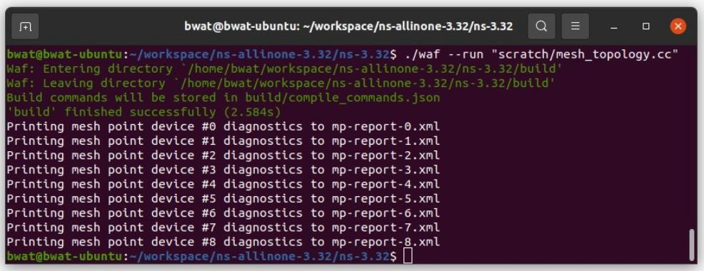

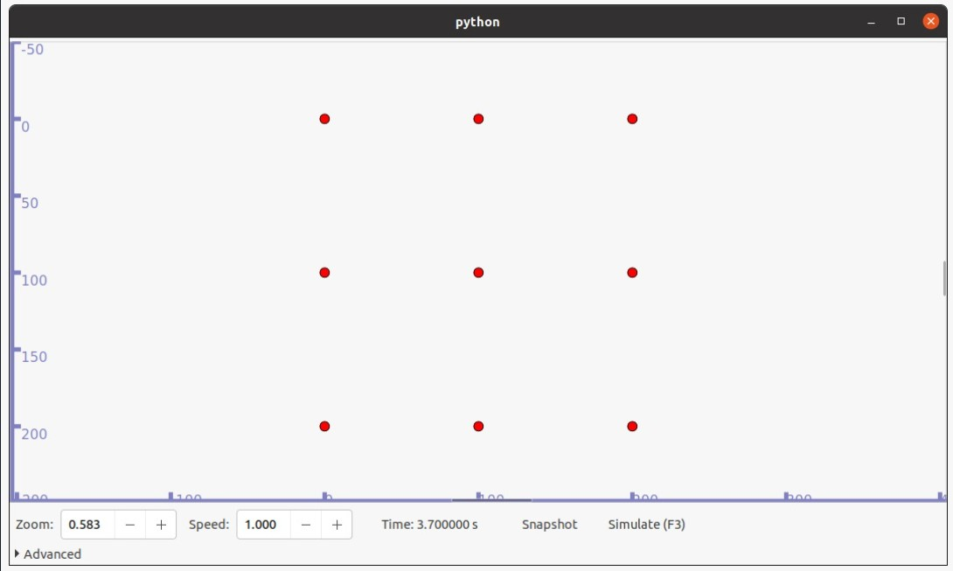

**Practical 12**

**Program to simulate hybrid topology**

**Code:**

**A] With NetAnim**

#include "ns3/netanim-module.h"

#include "ns3/core-module.h"

#include "ns3/point-to-point-module.h"

#include "ns3/network-module.h"

#include "ns3/applications-module.h"

#include "ns3/wifi-module.h"

#include "ns3/mobility-module.h"

#include "ns3/csma-module.h"

#include "ns3/internet-module.h"

#include “ns3/yans-wifi-helper.h”

#include “ns3/ssid.h”

// Default Network Topology

// Number of wifi or csma nodes can be increased up to 250

// Wifi 10.1.3.0

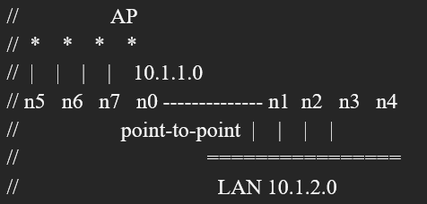

using namespace ns3;

NS_LOG_COMPONENT_DEFINE ("ThirdScriptExample");

int main (int argc, char *argv[])

{

bool verbose = true;

uint32_t nCsma = 3;

uint32_t nWifi = 3;

bool tracing = true;

CommandLine cmd;

cmd.AddValue ("nCsma", "Number of \"extra\" CSMA nodes/devices", nCsma);

cmd.AddValue ("nWifi", "Number of wifi STA devices", nWifi);

cmd.AddValue ("verbose", "Tell echo applications to log if true", verbose);

cmd.AddValue ("tracing", "Enable pcap tracing", tracing);

cmd.Parse (argc,argv);

// Check for valid number of csma or wifi nodes

// 250 should be enough, otherwise IP addresses

// soon become an issue

if (nWifi > 250 || nCsma > 250)

{

std::cout << "Too many wifi or csma nodes, no more than 250 each." << std::endl;

return 1;

}

if (verbose)

{

LogComponentEnable ("UdpEchoClientApplication", LOG_LEVEL_INFO);

LogComponentEnable ("UdpEchoServerApplication", LOG_LEVEL_INFO);

}

NodeContainer p2pNodes;

p2pNodes.Create (2);

PointToPointHelper pointToPoint;

pointToPoint.SetDeviceAttribute ("DataRate", StringValue ("5Mbps")); pointToPoint.SetChannelAttribute ("Delay", StringValue ("2ms"));

NetDeviceContainer p2pDevices;

p2pDevices = pointToPoint.Install (p2pNodes);

NodeContainer csmaNodes;

csmaNodes.Add (p2pNodes.Get (1));

csmaNodes.Create (nCsma);

CsmaHelper csma;

csma.SetChannelAttribute ("DataRate", StringValue ("100Mbps"));

csma.SetChannelAttribute ("Delay", TimeValue (NanoSeconds (6560)));

NetDeviceContainer csmaDevices;

csmaDevices = csma.Install (csmaNodes);

NodeContainer wifiStaNodes;

wifiStaNodes.Create (nWifi);

NodeContainer wifiApNode = p2pNodes.Get (0);

YansWifiChannelHelper channel = YansWifiChannelHelper::Default ();

YansWifiPhyHelper phy = YansWifiPhyHelper::Default ();

phy.SetChannel (channel.Create ());

WifiHelper wifi;

wifi.SetRemoteStationManager ("ns3::AarfWifiManager");

WifiMacHelper mac;

Ssid ssid = Ssid ("ns-3-ssid");

mac.SetType ("ns3::StaWifiMac", "Ssid", SsidValue (ssid), "ActiveProbing", BooleanValue (false));

NetDeviceContainer staDevices;

staDevices = wifi.Install (phy, mac, wifiStaNodes);

mac.SetType ("ns3::ApWifiMac", "Ssid", SsidValue (ssid));

NetDeviceContainer apDevices;

apDevices = wifi.Install (phy, mac, wifiApNode);

MobilityHelper mobility;

mobility.SetPositionAllocator ("ns3::GridPositionAllocator",

"MinX", DoubleValue (0.0),

"MinY", DoubleValue (0.0),

"DeltaX", DoubleValue (5.0),

"DeltaY", DoubleValue (10.0),

"GridWidth", UintegerValue (3),

"LayoutType", StringValue ("RowFirst"));

mobility.SetMobilityModel ("ns3::RandomWalk2dMobilityModel", "Bounds", RectangleValue (Rectangle (-50, 50, -50, 50)));

mobility.Install (wifiStaNodes);

mobility.SetMobilityModel ("ns3::ConstantPositionMobilityModel");

mobility.Install (wifiApNode);

InternetStackHelper stack;

stack.Install (csmaNodes);

stack.Install (wifiApNode);

stack.Install (wifiStaNodes);

Ipv4AddressHelper address;

address.SetBase ("10.1.1.0", "255.255.255.0");

Ipv4InterfaceContainer p2pInterfaces;

p2pInterfaces = address.Assign (p2pDevices);

address.SetBase ("10.1.2.0", "255.255.255.0");

Ipv4InterfaceContainer csmaInterfaces;

csmaInterfaces = address.Assign (csmaDevices);

address.SetBase ("10.1.3.0", "255.255.255.0");

address.Assign (staDevices);

address.Assign (apDevices);

UdpEchoServerHelper echoServer (9);

ApplicationContainer serverApps = echoServer.Install (csmaNodes.Get (nCsma));

serverApps.Start (Seconds (1.0));

serverApps.Stop (Seconds (10.0));

UdpEchoClientHelper echoClient (csmaInterfaces.GetAddress (nCsma), 9);

echoClient.SetAttribute ("MaxPackets", UintegerValue (1));

echoClient.SetAttribute ("Interval", TimeValue (Seconds (1.0)));

echoClient.SetAttribute ("PacketSize", UintegerValue (1024));

ApplicationContainer clientApps = echoClient.Install (wifiStaNodes.Get (nWifi - 1)); clientApps.Start (Seconds (2.0));

clientApps.Stop (Seconds (10.0));

Ipv4GlobalRoutingHelper::PopulateRoutingTables ();

Simulator::Stop (Seconds (10.0));

if (tracing == true)

{

pointToPoint.EnablePcapAll ("third");

phy.EnablePcap ("third", apDevices.Get (0));

csma.EnablePcap ("third", csmaDevices.Get (0), true);

}

//Netanim code

AnimationInterface anim ("third.xml");

anim.SetConstantPosition (csmaNodes.Get(1), 6, 10);

anim.SetConstantPosition (csmaNodes.Get(2), 9, 10);

anim.SetConstantPosition (csmaNodes.Get(3), 12, 10);

Simulator::Run ();

Simulator::Destroy ();

return 0;

}

**Output:**

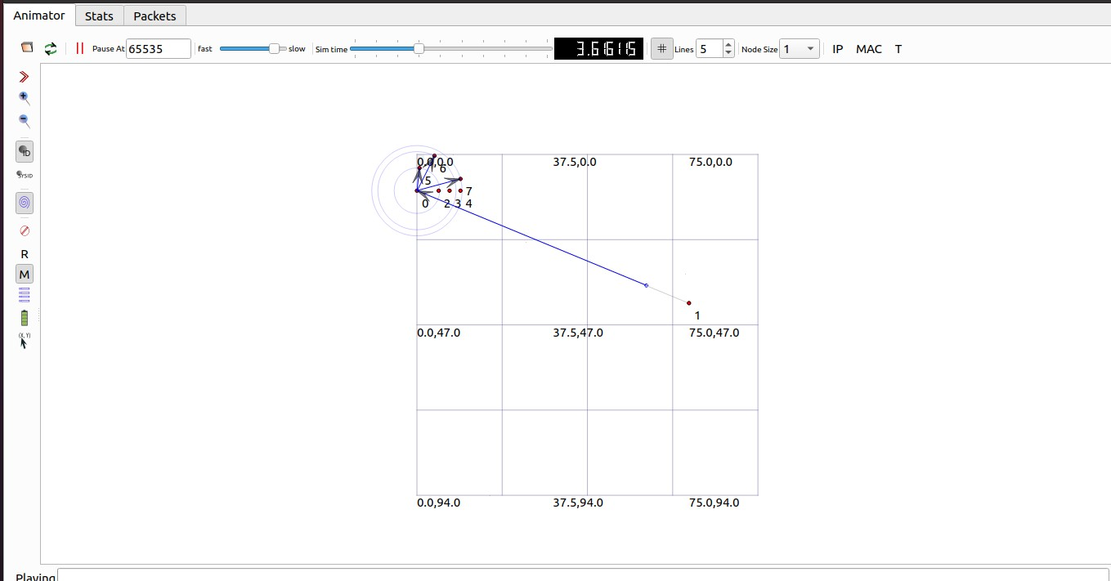

**B] Using vis**

**Code:**

#include "ns3/netanim-module.h" #include "ns3/core-module.h"

#include "ns3/point-to-point-module.h" #include "ns3/network-module.h" #include "ns3/applications-module.h" #include "ns3/wifi-module.h"

#include "ns3/mobility-module.h" #include "ns3/csma-module.h" #include "ns3/internet-module.h"

// Default Network Topology

// Number of wifi or csma nodes can be increased up to 250

// Wifi 10.1.3.0

// AP

using namespace ns3;

NS_LOG_COMPONENT_DEFINE ("ThirdScriptExample"); int

main (int argc, char *argv[])

{

bool verbose = true; uint32_t nCsma = 3; uint32_t nWifi = 3; bool tracing = true;

CommandLine cmd( FILE );

cmd.AddValue ("nCsma", "Number of \"extra\" CSMA nodes/devices", nCsma); cmd.AddValue ("nWifi", "Number of wifi STA devices", nWifi); cmd.AddValue ("verbose", "Tell echo applications to log if true", verbose); cmd.AddValue ("tracing", "Enable pcap tracing", tracing);

cmd.Parse (argc,argv);

// Check for valid number of csma or wifi nodes

// 250 should be enough, otherwise IP addresses

// soon become an issue if (nWifi>18)

{

std::cout << "Too many wifi or csma nodes, no more than 250 each." << std::endl; return 1;

}

if (verbose)

{

LogComponentEnable ("UdpEchoClientApplication", LOG_LEVEL_INFO); LogComponentEnable ("UdpEchoServerApplication", LOG_LEVEL_INFO);

}

NodeContainer p2pNodes; p2pNodes.Create (2); PointToPointHelper pointToPoint;

pointToPoint.SetDeviceAttribute ("DataRate", StringValue ("5Mbps")); pointToPoint.SetChannelAttribute ("Delay", StringValue ("2ms")); NetDeviceContainer p2pDevices;

p2pDevices = pointToPoint.Install (p2pNodes); NodeContainer csmaNodes;

csmaNodes.Add (p2pNodes.Get (1)); csmaNodes.Create (nCsma); CsmaHelper csma;

csma.SetChannelAttribute ("DataRate", StringValue ("100Mbps")); csma.SetChannelAttribute ("Delay", TimeValue (NanoSeconds (6560)));

NetDeviceContainer csmaDevices; csmaDevices = csma.Install (csmaNodes);

NodeContainer wifiStaNodes; wifiStaNodes.Create (nWifi);

NodeContainer wifiApNode = p2pNodes.Get (0); YansWifiChannelHelper channel = YansWifiChannelHelper::Default (); YansWifiPhyHelper phy = YansWifiPhyHelper::Default (); phy.SetChannel (channel.Create ());

WifiHelper wifi;

wifi.SetRemoteStationManager ("ns3::AarfWifiManager"); WifiMacHelper mac;

Ssid ssid = Ssid ("ns-3-ssid"); mac.SetType ("ns3::StaWifiMac",

"Ssid", SsidValue (ssid), "ActiveProbing", BooleanValue (false));

NetDeviceContainer staDevices;

staDevices = wifi.Install (phy, mac, wifiStaNodes); mac.SetType ("ns3::ApWifiMac",

"Ssid", SsidValue (ssid)); NetDeviceContainer apDevices;

apDevices = wifi.Install (phy, mac, wifiApNode); MobilityHelper mobility;

mobility.SetPositionAllocator ("ns3::GridPositionAllocator", "MinX", DoubleValue (0.0),

"MinY", DoubleValue (0.0),

"DeltaX", DoubleValue (5.0),

"DeltaY", DoubleValue (10.0),

"GridWidth", UintegerValue (3), "LayoutType", StringValue ("RowFirst"));

mobility.SetMobilityModel ("ns3::RandomWalk2dMobilityModel", "Bounds", RectangleValue (Rectangle (-50, 50, -50, 50))); mobility.Install (wifiStaNodes);

mobility.SetMobilityModel ("ns3::ConstantPositionMobilityModel"); mobility.Install (wifiApNode);

InternetStackHelper stack;

stack.Install (csmaNodes); stack.Install (wifiApNode); stack.Install (wifiStaNodes); Ipv4AddressHelper address;

address.SetBase ("10.1.1.0", "255.255.255.0");

Ipv4InterfaceContainer p2pInterfaces; p2pInterfaces = address.Assign (p2pDevices); address.SetBase ("10.1.2.0", "255.255.255.0");

Ipv4InterfaceContainer csmaInterfaces; csmaInterfaces = address.Assign (csmaDevices); address.SetBase ("10.1.3.0", "255.255.255.0");

address.Assign (staDevices); address.Assign (apDevices); UdpEchoServerHelper echoServer (9);

ApplicationContainer serverApps = echoServer.Install (csmaNodes.Get (nCsma)); serverApps.Start (Seconds (1.0));

serverApps.Stop (Seconds (10.0));

UdpEchoClientHelper echoClient (csmaInterfaces.GetAddress (nCsma), 9); echoClient.SetAttribute ("MaxPackets", UintegerValue (1)); echoClient.SetAttribute ("Interval", TimeValue (Seconds (1.0))); echoClient.SetAttribute ("PacketSize", UintegerValue (1024)); ApplicationContainer clientApps =

echoClient.Install (wifiStaNodes.Get (nWifi - 1)); clientApps.Start (Seconds (2.0));

clientApps.Stop (Seconds (10.0)); Ipv4GlobalRoutingHelper::PopulateRoutingTables (); Simulator::Stop (Seconds (10.0));

if (tracing == true)

{

pointToPoint.EnablePcapAll ("third"); phy.EnablePcap ("third", apDevices.Get (0)); csma.EnablePcap ("third", csmaDevices.Get (0), true);

}

Simulator::Run (); Simulator::Destroy (); return 0;

}

**Output:**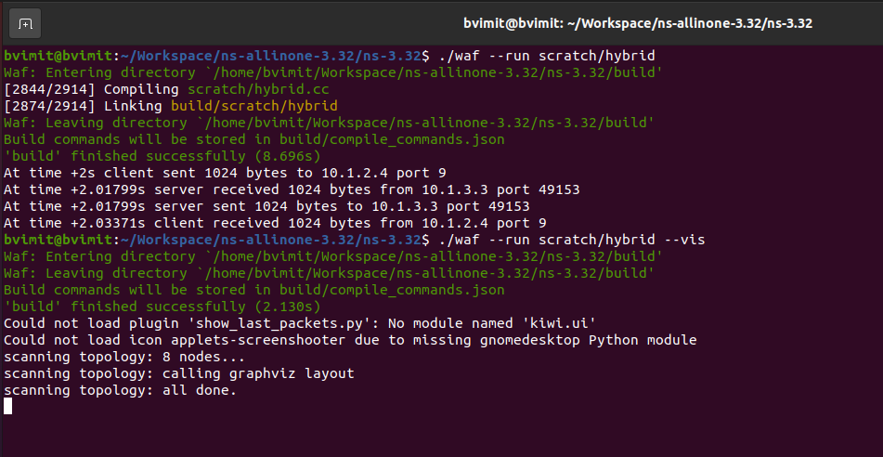

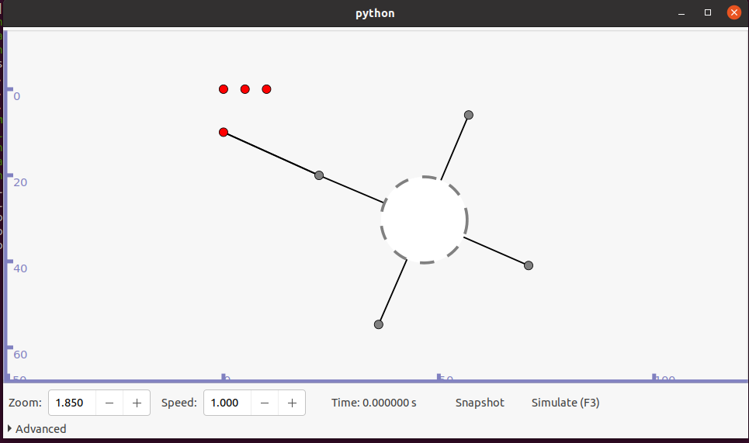

**With Wireshark**

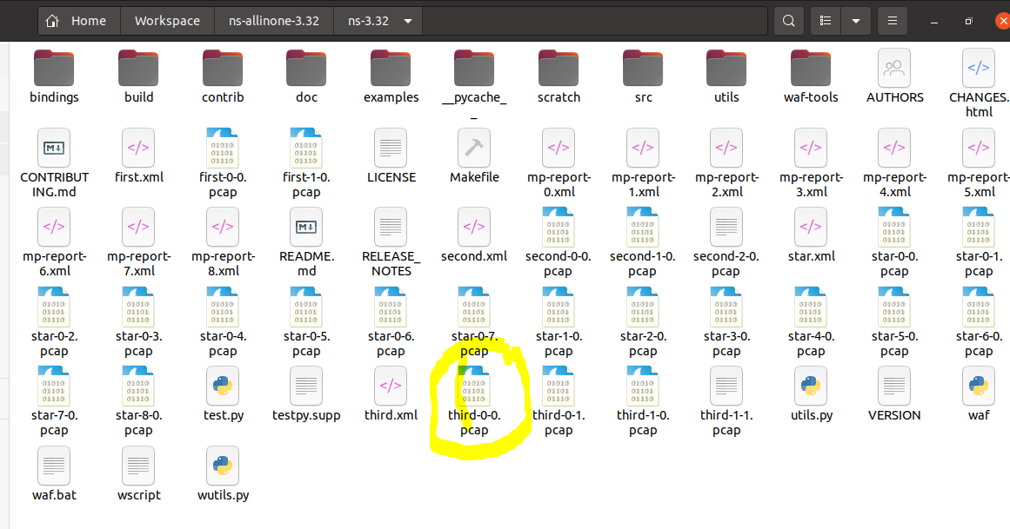

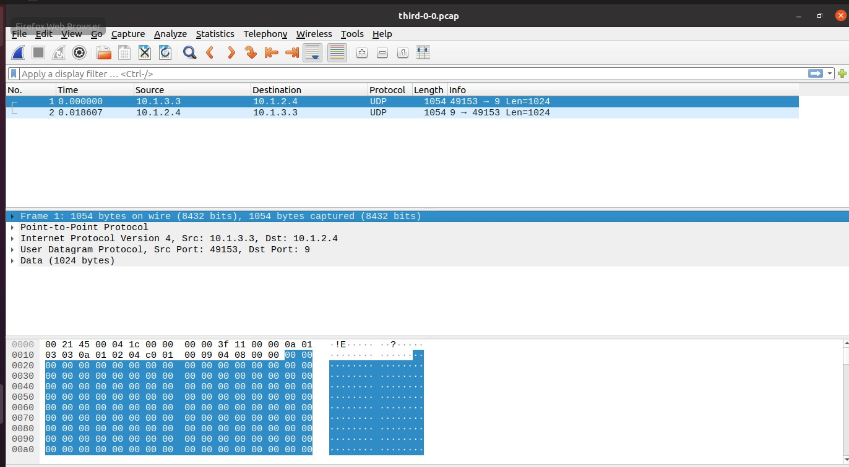

**Practical 13**

**Program to simulate UDP server client**

**Code:**

/* -*- Mode:C++; c-file-style:"gnu"; indent-tabs-mode:nil; -*- */

/*

* This program is free software; you can redistribute it and/or modify

* it under the terms of the GNU General Public License version 2 as

* published by the Free Software Foundation;

*

* This program is distributed in the hope that it will be useful,

* but WITHOUT ANY WARRANTY; without even the implied warranty of

* MERCHANTABILITY or FITNESS FOR A PARTICULAR PURPOSE. See the

* GNU General Public License for more details.

*

* You should have received a copy of the GNU General Public License

* along with this program; if not, write to the Free Software

* Foundation, Inc., 59 Temple Place, Suite 330, Boston, MA 02111-1307 USA

*/

// Network topology

//

// n0 n1

// | |

// =======

// LAN

//

// - UDP flows from n0 to n1 #include <fstream>

#include "ns3/core-module.h"

#include "ns3/csma-module.h"

#include "ns3/applications-module.h"

#include "ns3/internet-module.h"

using namespace ns3;

NS_LOG_COMPONENT_DEFINE ("UdpClientServerExample");

Int main (int argc, char *argv[])

{

//

// Enable logging for UdpClient and

//

LogComponentEnable ("UdpClient", LOG_LEVEL_INFO);

LogComponentEnable ("UdpServer", LOG_LEVEL_INFO);

bool useV6 = false;

Address serverAddress;

CommandLine cmd ( FILE );

cmd.AddValue ("useV6", "Use Ipv6", useV6);

cmd.Parse (argc, argv);

// Explicitly create the nodes required by the topology (shown above).

NS_LOG_INFO ("Create nodes.");

NodeContainer n;

n.Create (2);

InternetStackHelper internet;

internet.Install (n);

NS_LOG_INFO ("Create channels.");

// Explicitly create the channels required by the topology (shown above).

CsmaHelper csma;

csma.SetChannelAttribute ("DataRate", DataRateValue (DataRate (5000000))); csma.SetChannelAttribute ("Delay", TimeValue (MilliSeconds (2)));

csma.SetDeviceAttribute ("Mtu", UintegerValue (1400));

NetDeviceContainer d = csma.Install (n);

// We've got the "hardware" in place. Now we need to add IP addresses. NS_LOG_INFO ("Assign IP Addresses.");

if (useV6 == false)

{

Ipv4AddressHelper ipv4;

ipv4.SetBase ("10.1.1.0", "255.255.255.0");

Ipv4InterfaceContainer i = ipv4.Assign (d);

serverAddress = Address (i.GetAddress (1));

}

else

{

Ipv6AddressHelper ipv6;

ipv6.SetBase ("2001:0000:f00d:cafe::", Ipv6Prefix (64));

Ipv6InterfaceContainer i6 = ipv6.Assign (d);

serverAddress = Address(i6.GetAddress (1,1));

}

NS_LOG_INFO ("Create Applications.");

// Create one udpServer applications on node one.

uint16_t port = 4000;

UdpServerHelper server (port);

ApplicationContainer apps = server.Install (n.Get (1));

apps.Start (Seconds (1.0));

apps.Stop (Seconds (10.0));

// Create one UdpClient application to send UDP datagrams from node zero to node one.

uint32_t MaxPacketSize = 1024;

Time interPacketInterval = Seconds (0.05);

uint32_t maxPacketCount = 320;

UdpClientHelper client (serverAddress, port);

client.SetAttribute ("MaxPackets", UintegerValue (maxPacketCount));

client.SetAttribute ("Interval", TimeValue (interPacketInterval));

client.SetAttribute ("PacketSize", UintegerValue (MaxPacketSize));

apps = client.Install (n.Get (0));

apps.Start (Seconds (2.0));

apps.Stop (Seconds (10.0));

//

// Now, do the actual simulation.

//

NS_LOG_INFO ("Run Simulation.");

Simulator::Run ();

Simulator::Destroy ();

NS_LOG_INFO ("Done.");

}

**Output:**

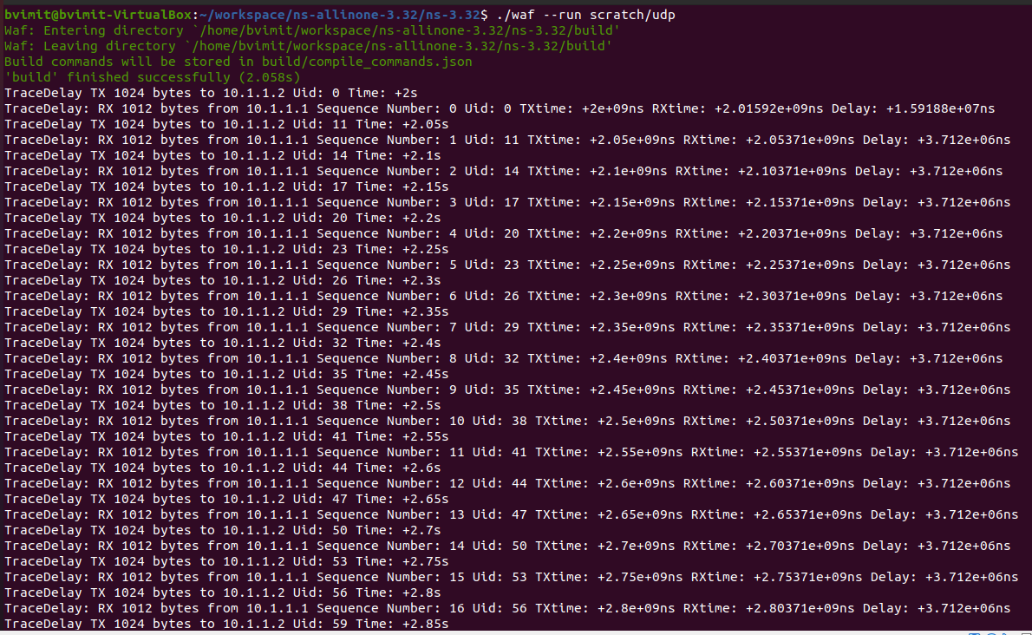

Using --vis



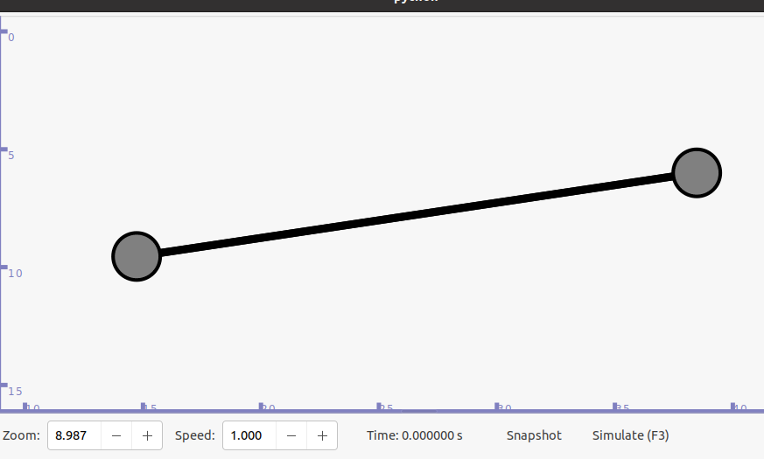

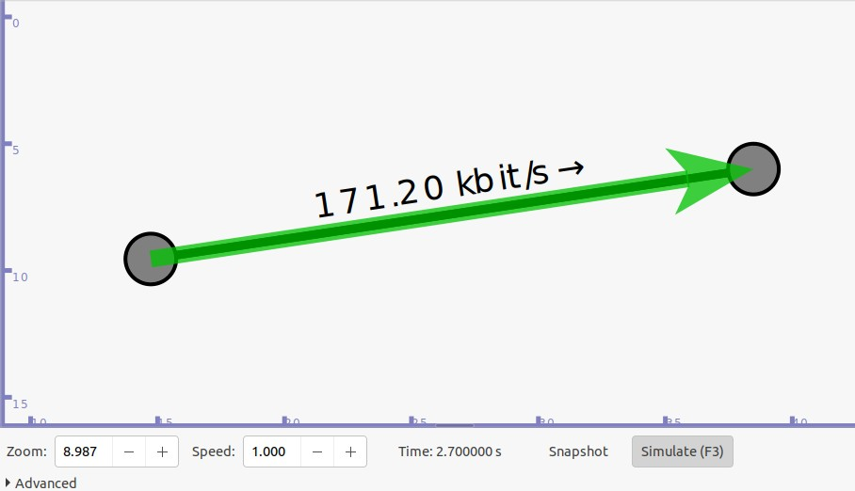

For command line input:

./waf --run “scratch/udp --use V6=true”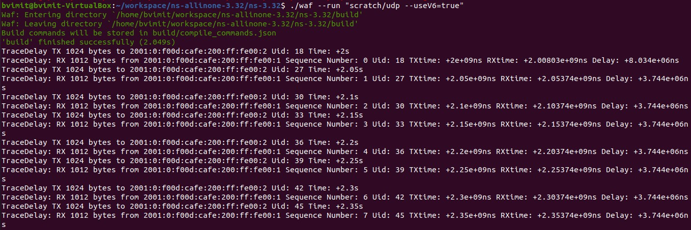

**Practical 14**

**Program to simulate DHCP server and n clients**

**Code:**

#include "ns3/core-module.h" #include "ns3/network-module.h" #include "ns3/internet-apps-module.h" #include "ns3/csma-module.h" #include "ns3/internet-module.h"

#include "ns3/point-to-point-module.h" #include "ns3/applications-module.h" using namespace ns3;

NS_LOG_COMPONENT_DEFINE ("DhcpExample"); int

main (int argc, char *argv[])

{

CommandLine cmd ( FILE ); bool verbose = false;

bool tracing = false;

cmd.AddValue ("verbose", "turn on the logs", verbose); cmd.AddValue ("tracing", "turn on the tracing", tracing); cmd.Parse (argc, argv);

// GlobalValue::Bind ("ChecksumEnabled", BooleanValue (true)); if (verbose)

{

LogComponentEnable ("DhcpServer", LOG_LEVEL_ALL); LogComponentEnable ("DhcpClient", LOG_LEVEL_ALL); LogComponentEnable ("UdpEchoServerApplication", LOG_LEVEL_INFO); LogComponentEnable ("UdpEchoClientApplication", LOG_LEVEL_INFO);

}

Time stopTime = Seconds (20); NS_LOG_INFO ("Create nodes."); NodeContainer nodes; NodeContainer router; nodes.Create (3);

router.Create (2);

NodeContainer net (nodes, router); NS_LOG_INFO ("Create channels."); CsmaHelper csma;

csma.SetChannelAttribute ("DataRate", StringValue ("5Mbps")); csma.SetChannelAttribute ("Delay", StringValue ("2ms"));

csma.SetDeviceAttribute ("Mtu", UintegerValue (1500)); NetDeviceContainer devNet = csma.Install (net); NodeContainer p2pNodes;

p2pNodes.Add (net.Get (4));

p2pNodes.Create (1); PointToPointHelper pointToPoint;

pointToPoint.SetDeviceAttribute ("DataRate", StringValue ("5Mbps")); pointToPoint.SetChannelAttribute ("Delay", StringValue ("2ms")); NetDeviceContainer p2pDevices;

p2pDevices = pointToPoint.Install (p2pNodes); InternetStackHelper tcpip;

tcpip.Install (nodes); tcpip.Install (router); tcpip.Install (p2pNodes.Get (1)); Ipv4AddressHelper address;

address.SetBase ("172.30.1.0", "255.255.255.0");

Ipv4InterfaceContainer p2pInterfaces; p2pInterfaces = address.Assign (p2pDevices);

// manually add a routing entry because we don't want to add a dynamic routing Ipv4StaticRoutingHelper ipv4RoutingHelper;

Ptr<Ipv4> ipv4Ptr = p2pNodes.Get (1)->GetObject<Ipv4> ();

Ptr<Ipv4StaticRouting> staticRoutingA = ipv4RoutingHelper.GetStaticRouting (ipv4Ptr); staticRoutingA->AddNetworkRouteTo (Ipv4Address ("172.30.0.0"), Ipv4Mask ("/24"), Ipv4Address ("172.30.1.1"), 1);

NS_LOG_INFO ("Setup the IP addresses and create DHCP applications."); DhcpHelper dhcpHelper;

// The router must have a fixed IP.

Ipv4InterfaceContainer fixedNodes = dhcpHelper.InstallFixedAddress (devNet.Get (4), Ipv4Address ("172.30.0.17"), Ipv4Mask ("/24"));

// Not really necessary, IP forwarding is enabled by default in IPv4. fixedNodes.Get (0).first->SetAttribute ("IpForward", BooleanValue (true));

// DHCP server

ApplicationContainer dhcpServerApp = dhcpHelper.InstallDhcpServer (devNet.Get (3), Ipv4Address ("172.30.0.12"),

Ipv4Address ("172.30.0.0"), Ipv4Mask ("/24"), Ipv4Address ("172.30.0.10"), Ipv4Address ("172.30.0.15"),

Ipv4Address ("172.30.0.17"));

// This is just to show how it can be done.

DynamicCast<DhcpServer> (dhcpServerApp.Get (0))->AddStaticDhcpEntry (devNet.Get (2)-

>GetAddress (), Ipv4Address ("172.30.0.14"));

dhcpServerApp.Start (Seconds (0.0)); dhcpServerApp.Stop (stopTime);

// DHCP clients

NetDeviceContainer dhcpClientNetDevs; dhcpClientNetDevs.Add (devNet.Get (0));

dhcpClientNetDevs.Add (devNet.Get (1));

dhcpClientNetDevs.Add (devNet.Get (2));

ApplicationContainer dhcpClients = dhcpHelper.InstallDhcpClient (dhcpClientNetDevs); dhcpClients.Start (Seconds (1.0));

dhcpClients.Stop (stopTime); UdpEchoServerHelper echoServer (9);

ApplicationContainer serverApps = echoServer.Install (p2pNodes.Get (1)); serverApps.Start (Seconds (0.0));

serverApps.Stop (stopTime);

UdpEchoClientHelper echoClient (p2pInterfaces.GetAddress (1), 9); echoClient.SetAttribute ("MaxPackets", UintegerValue (100)); echoClient.SetAttribute ("Interval", TimeValue (Seconds (1.0))); echoClient.SetAttribute ("PacketSize", UintegerValue (1024)); ApplicationContainer clientApps = echoClient.Install (nodes.Get (1)); clientApps.Start (Seconds (10.0));

clientApps.Stop (stopTime);

Simulator::Stop (stopTime + Seconds (10.0)); if (tracing)

{

csma.EnablePcapAll ("dhcp-csma"); pointToPoint.EnablePcapAll ("dhcp-p2p");

}

NS_LOG_INFO ("Run Simulation."); Simulator::Run (); Simulator::Destroy (); NS_LOG_INFO ("Done.");

}

**Output:**

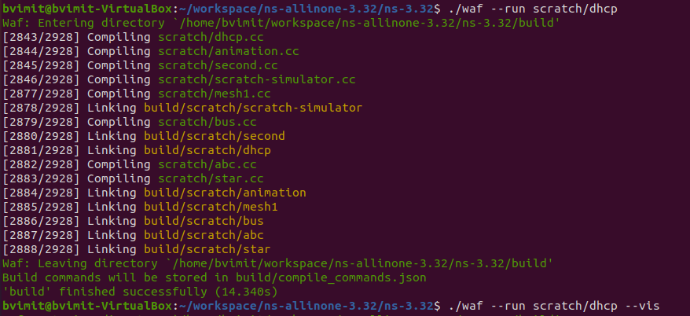

**Using --vis**

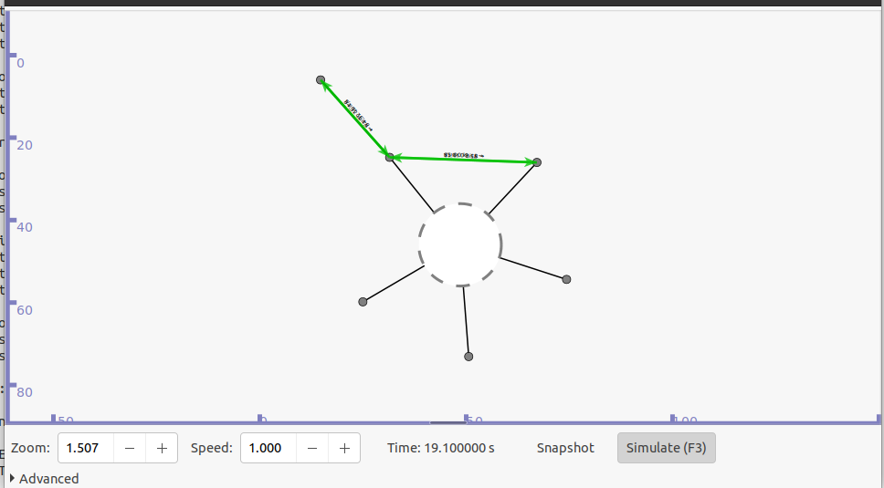

**Practical 15**

**Program to simulate FTP using TCP protocol**

**Code:**

#include "ns3/core-module.h"

#include "ns3/network-module.h"

#include "ns3/internet-module.h"

#include "ns3/point-to-point-module.h"

#include "ns3/applications-module.h"

#include "ns3/csma-module.h"

#include "ns3/ipv4-global-routing-helper.h"

using namespace ns3;

NS_LOG_COMPONENT_DEFINE ("FTP_Simulation");

int main(int argc, char *argv[])

{

Time::SetResolution (Time::NS);

LogComponentEnable ("OnOffApplication", LOG_LEVEL_INFO);

LogComponentEnable ("OnOffApplication", LOG_LEVEL_INFO);

NodeContainer csmaNodes;

csmaNodes.Create(2);

// using csma helper to configure attributes

// and creating connectivity between two nodes

CsmaHelper csma;

// set channel attributes for device

csma.SetChannelAttribute ("DataRate",StringValue("1Mbps"));

csma.SetChannelAttribute ("Delay",StringValue("20ms"));

// installing nodes to create, configure, install devices of required type

NetDeviceContainer csmaDevices;

csmaDevices = csma.Install(csmaNodes);

// installing protocol stack in nodes; once executed will install TCP,UDP, IP etc. on each node of the nodeContainer

InternetStackHelper stack;

stack.Install(csmaNodes);

// assigning IP address to the devices, setting base address here

Ipv4AddressHelper address;

address.SetBase ("10.10.10.0","255.255.255.0");

Ipv4InterfaceContainer csmaInterfaces =address.Assign(csmaDevices);

// assigning ip address to the devices, since devices contain nodes, while ip stack is created within a node

// unint32_t port_num=21; // port number for Rx

Address RxAddress(InetSocketAddress (csmaInterfaces.GetAddress(1), 21)); //Rx obtaining a IPv4 //address, and the port number to listen

PacketSinkHelper sinkHelper ("ns3::TcpSocketFactory", RxAddress); // PacketSinkHelper is a class //reference for creating socket references and passing address at which Rx is instantiated

ApplicationContainer sinkApp = sinkHelper.Install (csmaNodes.Get(1)); // ApplicationContainer, //installs application on the node, in our case it is packet sink helper ; node here is the server node

sinkApp.Start (Seconds (1.0));

sinkApp.Stop (Seconds (10.0));

//creating a TCP transmitter

// set up address and port number to send TCP traffic to the server

Address TxAddress(InetSocketAddress(csmaInterfaces.GetAddress(1),21));

OnOffHelper clientHelper ("ns3::TcpSocketFactory", TxAddress);

// setting up attributes for onoff application helper

clientHelper.SetAttribute("DataRate",StringValue("1Mbps")); clientHelper.SetAttribute("PacketSize",UintegerValue(1280));

ApplicationContainer Tx = clientHelper.Install (csmaNodes.Get (0));

Tx.Start (Seconds (1.0));

Tx.Stop (Seconds (10.0));

csma.EnablePcap("ftpeg",csmaDevices.Get(1),true);

AsciiTraceHelper ascii;

csma.EnableAsciiAll(ascii.CreateFileStream ("ftp_trace.tr"));

NS_LOG_INFO ("Run Simulation.");

Simulator::Run ();

NS_LOG_INFO ("Done");

return(0);

}

**Output:**

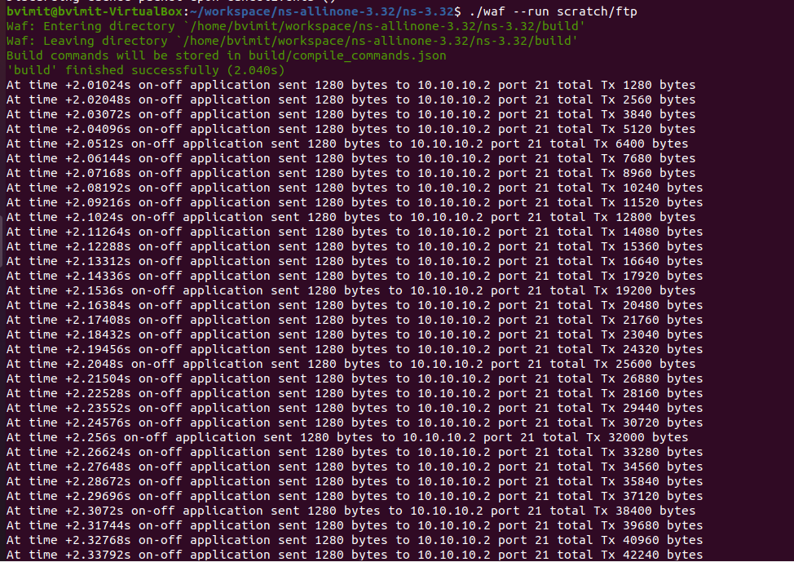

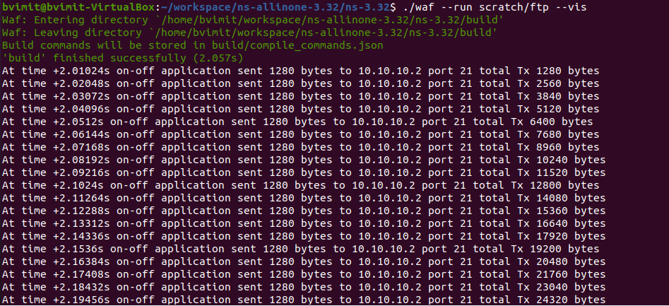

**Practical 16**

**Program to simulate Three-way handshake for TCP connection using NetAnim**

**Code:**

#include <iostream>

#include <fstream>

#include <string>

#include <cassert>

#include "ns3/core-module.h"

#include "ns3/network-module.h"

#include "ns3/internet-module.h"

#include "ns3/point-to-point-module.h"

#include "ns3/applications-module.h"

#include "ns3/ipv4-global-routing-helper.h"

#include "ns3/netanim-module.h"

using namespace ns3;

NS_LOG_COMPONENT_DEFINE ("TcpServer");

int main (int argc, char *argv[])

{

// Users may find it convenient to turn on explicit debugging

// for selected modules; the below lines suggest how to do this

//LogComponentEnable ("TcpServer", LOG_LEVEL_INFO);

//LogComponentEnable ("TcpL4Protocol", LOG_LEVEL_ALL);

//LogComponentEnable ("TcpSocketImpl", LOG_LEVEL_ALL);

//LogComponentEnable ("PacketSink", LOG_LEVEL_ALL);

// Set up some default values for the simulation.

Config::SetDefault ("ns3::OnOffApplication::PacketSize",UintegerValue (250));

Config::SetDefault ("ns3::OnOffApplication::DataRate", StringValue ("5kb/s"));

uint32_t N = 5; //number of nodes in the star

// Allow the user to override any of the defaults and the above

// Config::SetDefault()s at run-time, via command-line arguments CommandLine cmd;

cmd.AddValue ("nNodes", "Number of nodes to place in the star", N); cmd.Parse (argc, argv);

// Here, we will create N nodes in a star.

NS_LOG_INFO ("Create nodes.");

NodeContainer serverNode;

NodeContainer clientNodes;

serverNode.Create (1);

clientNodes.Create (N-1);

NodeContainer allNodes = NodeContainer (serverNode, clientNodes);

// Install network stacks on the nodes

InternetStackHelper internet;

internet.Install (allNodes);

//Collect an adjacency list of nodes for the p2p topology

std::vector<NodeContainer> nodeAdjacencyList (N-1);

for(uint32_t i=0; i<nodeAdjacencyList.size (); ++i)

{

nodeAdjacencyList[i] = NodeContainer (serverNode, clientNodes.Get (i));

}

// We create the channels first without any IP addressing information

NS_LOG_INFO ("Create channels.");

PointToPointHelper p2p;

p2p.SetDeviceAttribute ("DataRate", StringValue ("5Mbps"));

p2p.SetChannelAttribute ("Delay", StringValue ("2ms"));

std::vector<NetDeviceContainer> deviceAdjacencyList (N-1);

for(uint32_t i=0; i<deviceAdjacencyList.size (); ++i)

{

deviceAdjacencyList[i] = p2p.Install (nodeAdjacencyList[i]);

}

// Later, we add IP addresses.

NS_LOG_INFO ("Assign IP Addresses.");

Ipv4AddressHelper ipv4;

std::vector<Ipv4InterfaceContainer> interfaceAdjacencyList (N-1);

for(uint32_t i=0; i<interfaceAdjacencyList.size (); ++i)

{

std::ostringstream subnet; subnet<<"10.1."<<i+1<<".0";

ipv4.SetBase (subnet.str ().c_str (), "255.255.255.0");

interfaceAdjacencyList[i] = ipv4.Assign (deviceAdjacencyList[i]);

}

//Turn on global static routing Ipv4GlobalRoutingHelper::PopulateRoutingTables ();

// Create a packet sink on the star "hub" to receive these packets

uint16_t port = 50000;

Address sinkLocalAddress (InetSocketAddress (Ipv4Address::GetAny (), port));

PacketSinkHelper sinkHelper ("ns3::TcpSocketFactory", sinkLocalAddress);

ApplicationContainer sinkApp = sinkHelper.Install (serverNode);

sinkApp.Start (Seconds (1.0));

sinkApp.Stop (Seconds (10.0));

// Create the OnOff applications to send TCP to the server OnOffHelper clientHelper ("ns3::TcpSocketFactory", Address ());

clientHelper.SetAttribute ("OnTime", StringValue ("ns3::ConstantRandomVariable[Constant=1]")); clientHelper.SetAttribute ("OffTime", StringValue ("ns3::ConstantRandomVariable[Constant=0]"));

//normally wouldn't need a loop here but the server IP address is different

//on each p2p subnet

ApplicationContainer clientApps;

for(uint32_t i=0; i<clientNodes.GetN (); ++i)

{

AddressValue remoteAddress

(InetSocketAddress (interfaceAdjacencyList[i].GetAddress (0), port));

clientHelper.SetAttribute ("Remote", remoteAddress);

clientApps.Add (clientHelper.Install (clientNodes.Get (i)));

}

clientApps.Start (Seconds (1.0));

clientApps.Stop (Seconds (10.0));

//configure tracing AsciiTraceHelper ascii;

p2p.EnableAsciiAll (ascii.CreateFileStream ("tcp-star-server.tr"));

p2p.EnablePcapAll ("tcp-star-server");

NS_LOG_INFO ("Run Simulation.");

AnimationInterface anim ("Anim.xml");

anim.EnablePacketMetadata (true);

Simulator::Run ();

Simulator::Destroy ();

NS_LOG_INFO ("Done.");

return 0;

}

**Output:**

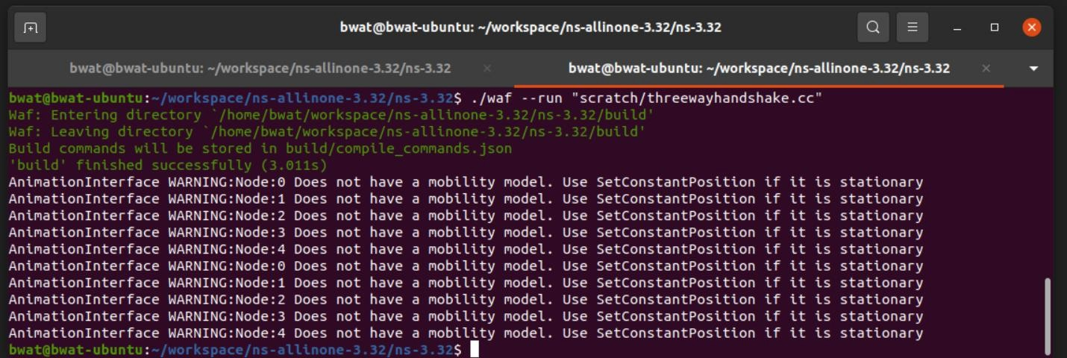

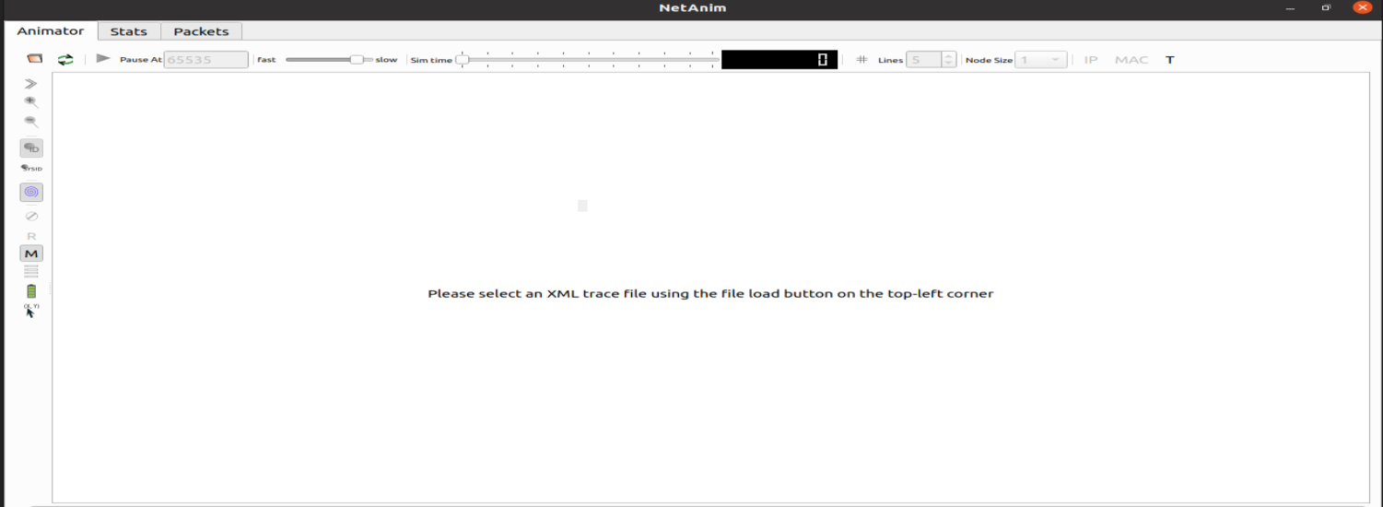**./NetAnim**

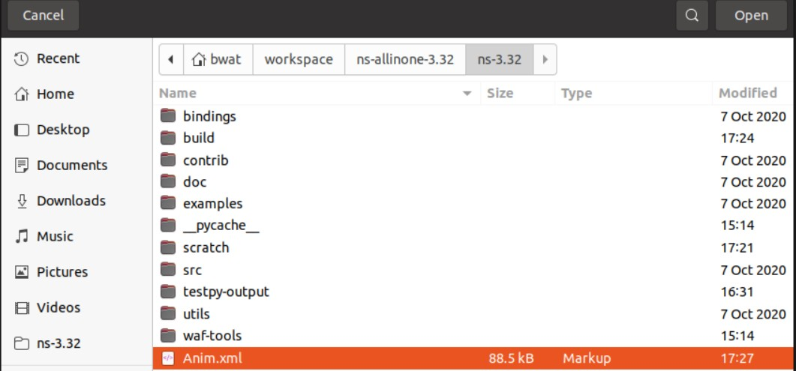

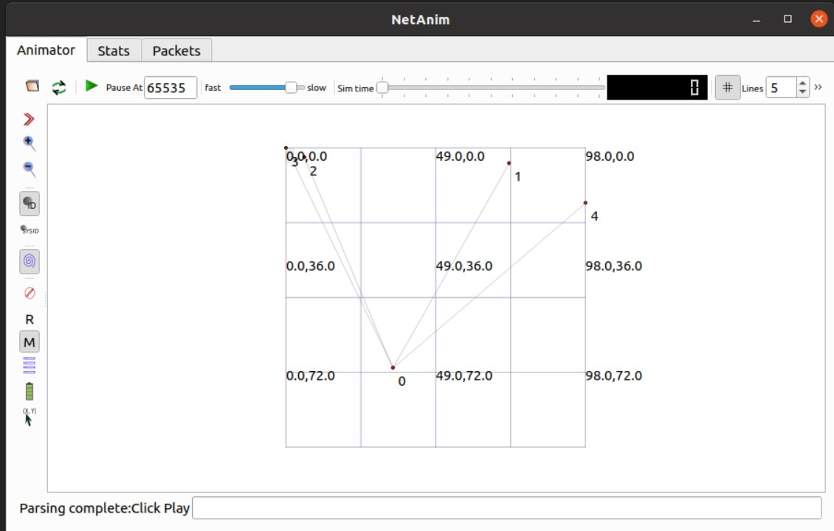

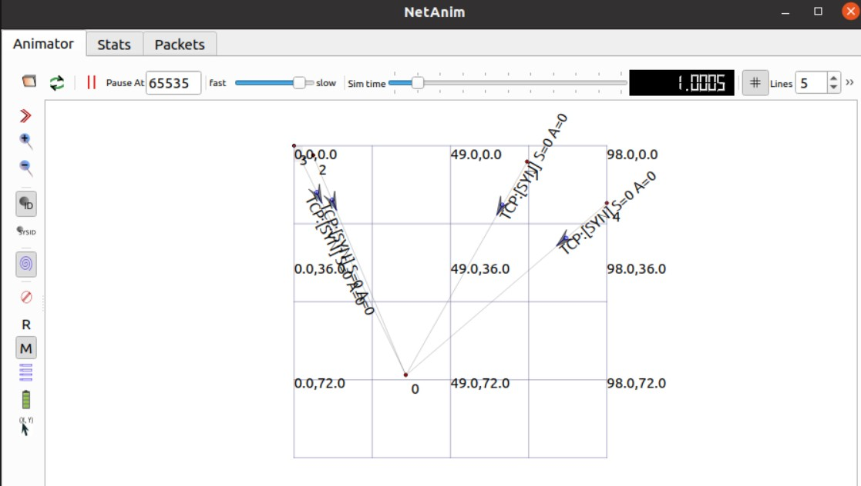

**Practical 17**

**Analyze the network traffic using WireShark**

Step 1: Open Wireshark and select the network connection which is Wifi in this case.

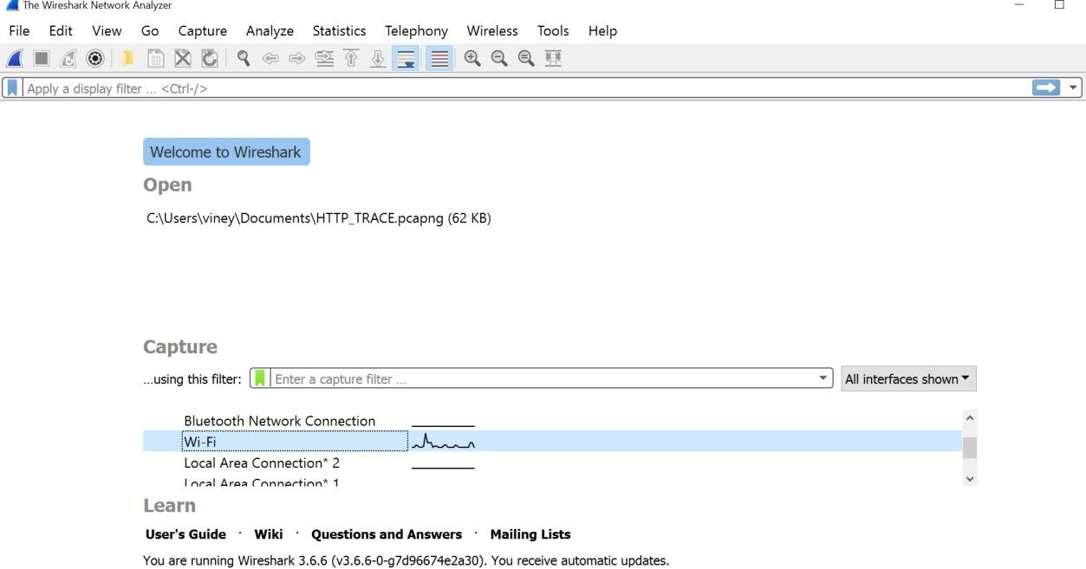

Step 2: Start capturing packets which will record the browsing history. And then stop capturing.

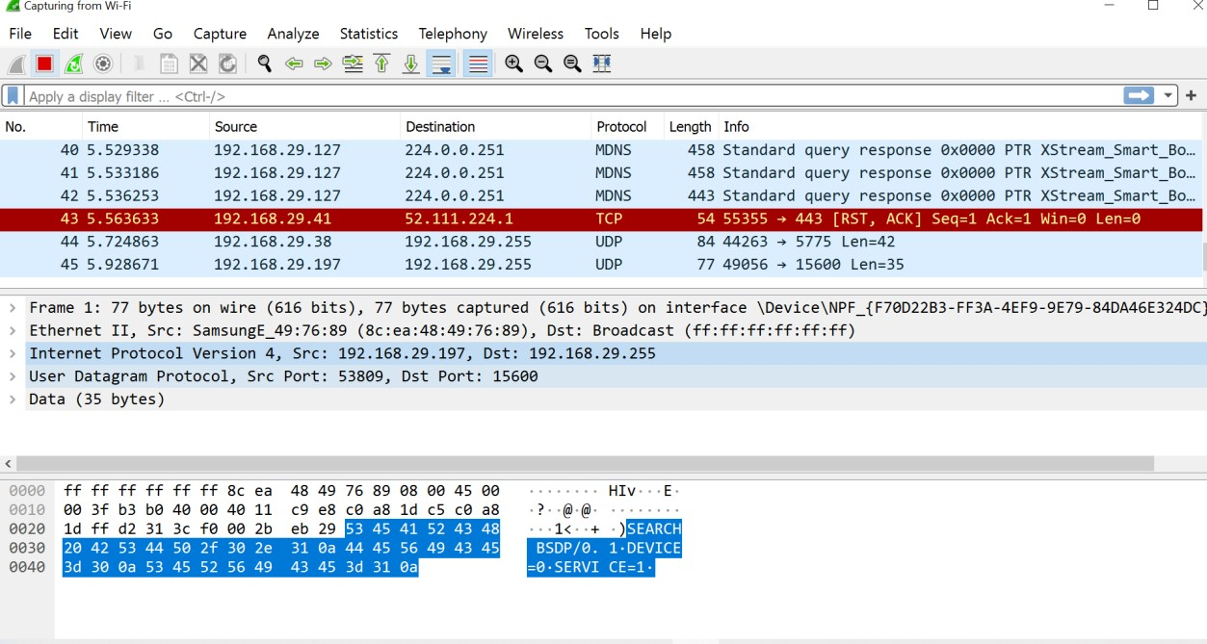

Step 3: Search for all tcp protocol packets.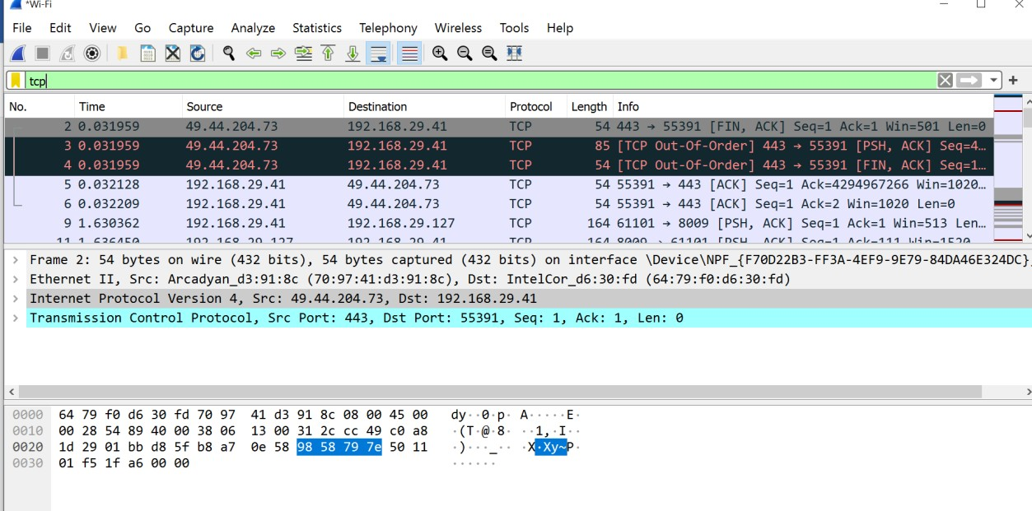

You can select any packets to get the information about that.

Then expand Ethernet column to get additional details.

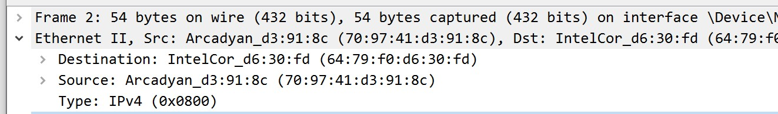

Then expand Transmission Control Protocol column to get additional details.

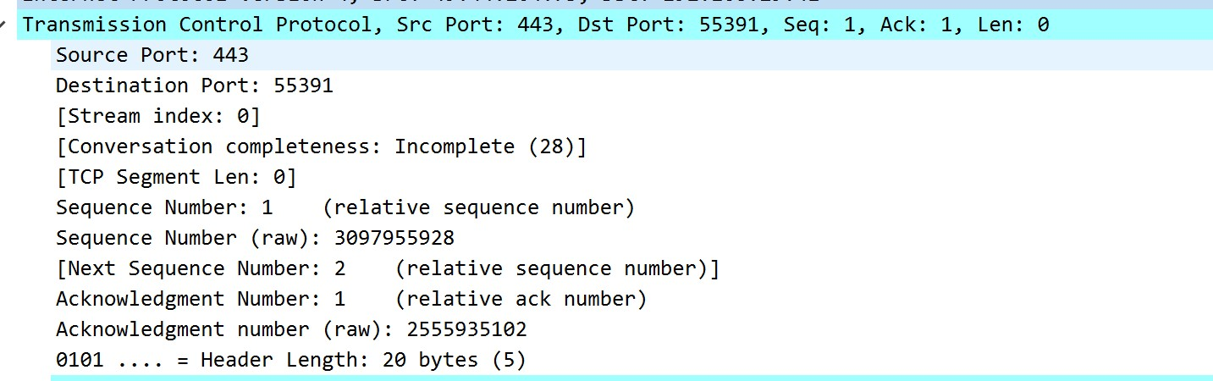

You can analyze the statistics graphically. Click on the statistics option.

Click on I/O Graphs.

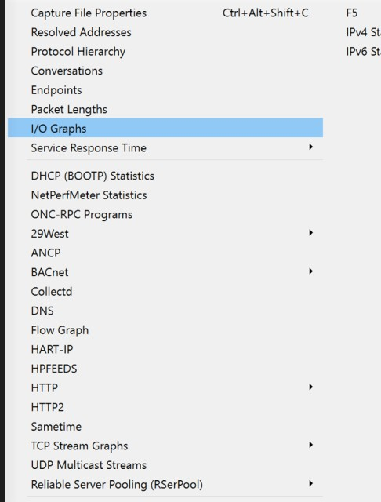

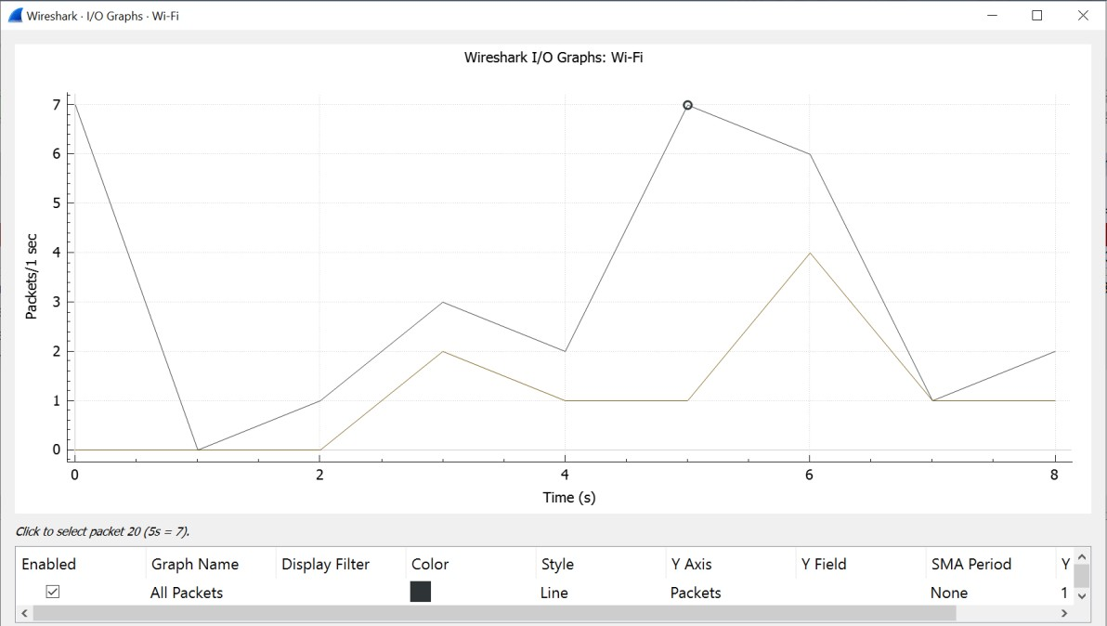

Step 4: Search for all http protocol packets.

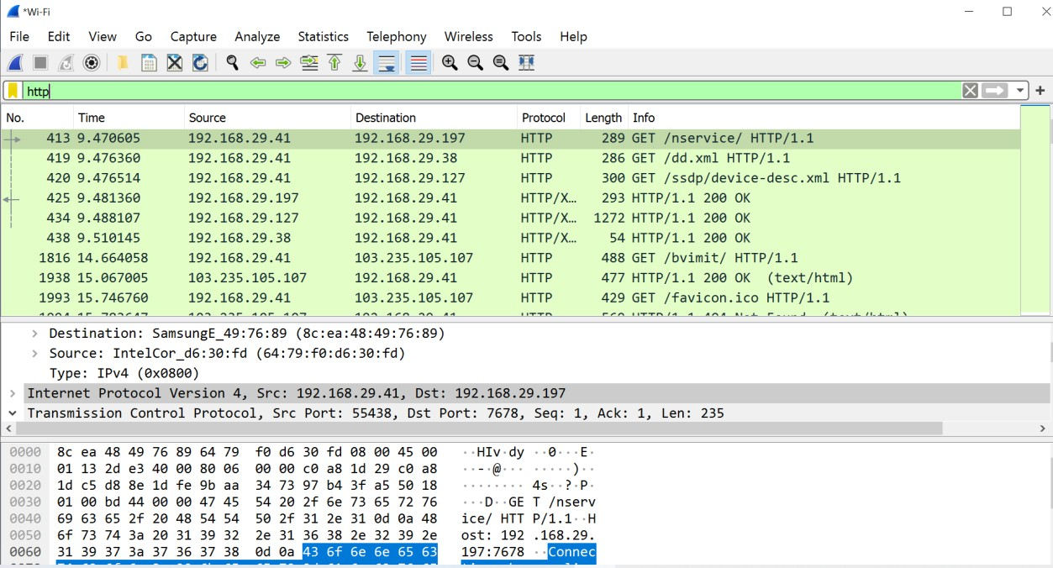

Step 5: Search for all http request protocol packets with GET method.

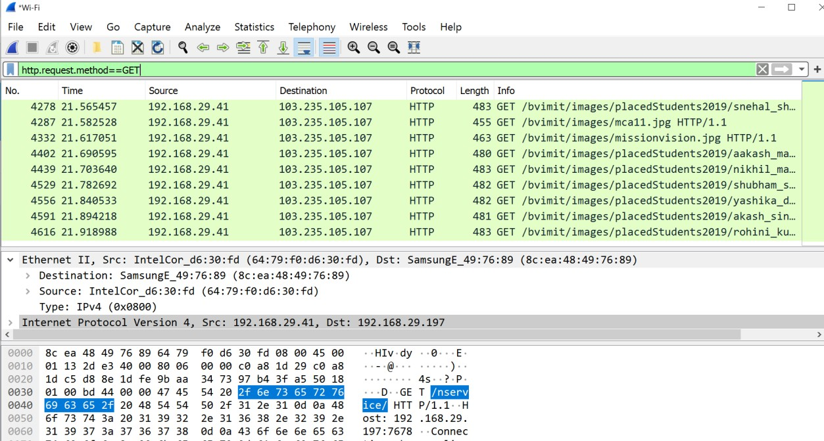

Step 6: Search for all http response protocol packets.

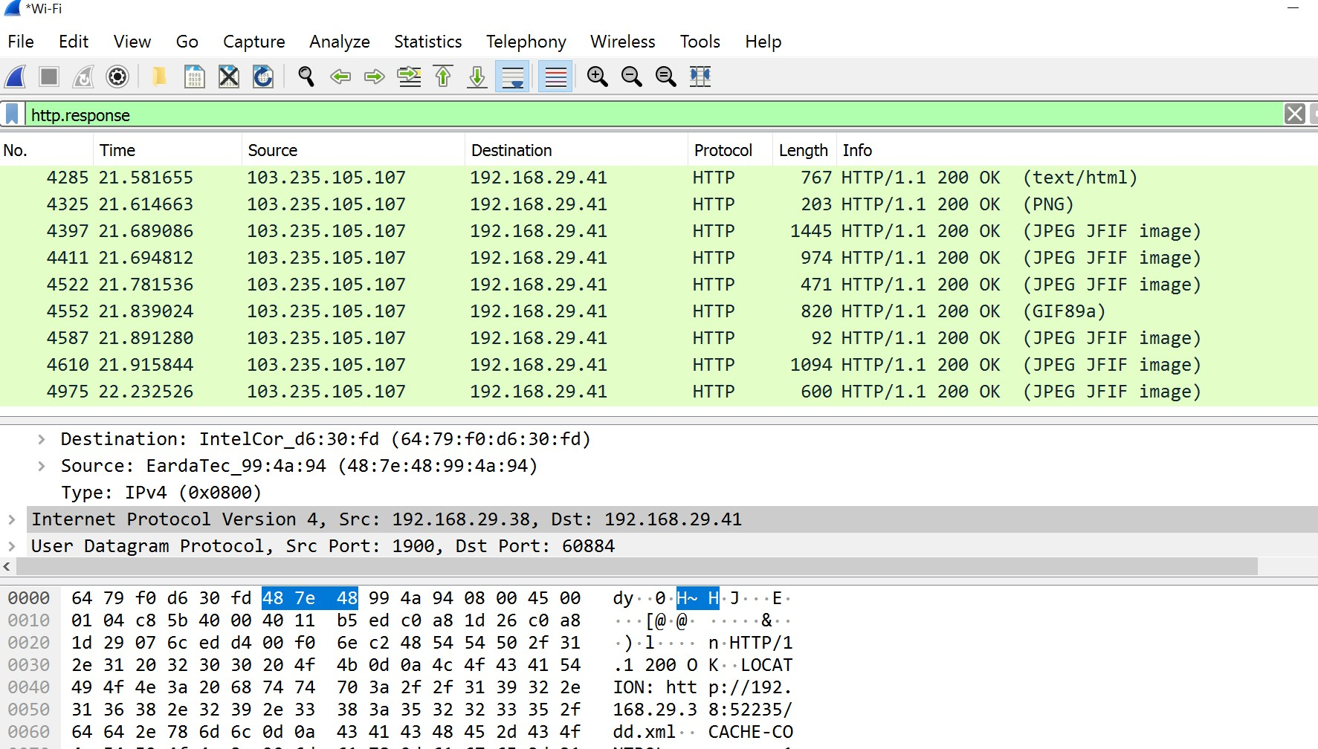

**Practical 18 – Mini Project**

**DYNAMIC GLOBAL ROUTING**

**Aim:** Revolve around optimising network performance, ensuring fault tolerance, enabling scalability, and enhancing security in a complex and interconnected global network infrastructure.

**Objective:** The objective of Dynamic Global Routing is to efficiently and effectively manage network traffic flow in a global network infrastructure. It involves dynamically determining the optimal path for data packets to travel from the source to the destination across multiple interconnected networks.

**Code:**

// Network topology

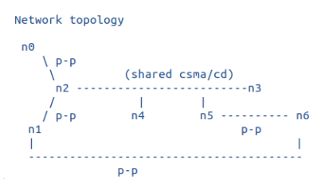

// - at time 1 CBR/UDP flow from n1 to n6's IP address on the n5/n6 link

// - at time 10, start similar flow from n1 to n6's address on the n1/n6 link

//

// Order of events

// At pre-simulation time, configure global routes. Shortest path from

// n1 to n6 is via the direct point-to-point link

// At time 1s, start CBR traffic flow from n1 to n6

// At time 2s, set the n1 point-to-point interface to down. Packets

// will be diverted to the n1-n2-n5-n6 path

// At time 4s, re-enable the n1/n6 interface to up. n1-n6 route restored.

// At time 6s, set the n6-n1 point-to-point Ipv4 interface to down (note, this

// keeps the point-to-point link "up" from n1's perspective). Traffic will

// flow through the path n1-n2-n5-n6

// At time 8s, bring the interface back up. Path n1-n6 is restored

// At time 10s, stop the first flow.

// At time 11s, start a new flow, but to n6's other IP address (the one

// on the n1/n6 p2p link)

// At time 12s, bring the n1 interface down between n1 and n6. Packets

// will be diverted to the alternate path

// At time 14s, re-enable the n1/n6 interface to up. This will change

// routing back to n1-n6 since the interface up notification will cause

// a new local interface route, at higher priority than global routing

// At time 16s, stop the second flow.

// - Tracing of queues and packet receptions to file "dynamic-global-routing.tr"

#include <iostream>

#include <fstream>

#include <string>

#include <cassert>

#include "ns3/core-module.h"

#include "ns3/network-module.h"

#include "ns3/csma-module.h"

#include "ns3/internet-module.h"

#include "ns3/point-to-point-module.h"

#include "ns3/applications-module.h"

#include "ns3/ipv4-global-routing-helper.h"

#include “ns3/netanim-module.h”

using namespace ns3;

NS_LOG_COMPONENT_DEFINE ("DynamicGlobalRoutingExample");

Int main (int argc, char *argv[])

{

// The below value configures the default behavior of global routing.

// By default, it is disabled. To respond to interface events, set to true

Config::SetDefault ("ns3::Ipv4GlobalRouting::RespondToInterfaceEvents", BooleanValue (true));

// Allow the user to override any of the defaults and the above

// Bind ()s at run-time, via command-line arguments

CommandLine cmd (__FILE__);

cmd.Parse (argc, argv);

NS_LOG_INFO ("Create nodes.");

NodeContainer c;

c.Create (7);

NodeContainer n0n2 = NodeContainer (c.Get (0), c.Get (2));

NodeContainer n1n2 = NodeContainer (c.Get (1), c.Get (2));

NodeContainer n5n6 = NodeContainer (c.Get (5), c.Get (6));

NodeContainer n1n6 = NodeContainer (c.Get (1), c.Get (6));

NodeContainer n2345 = NodeContainer (c.Get (2), c.Get (3), c.Get (4), c.Get (5));

InternetStackHelper internet;

internet.Install (c);

// We create the channels first without any IP addressing information

NS_LOG_INFO ("Create channels.");

PointToPointHelper p2p;

p2p.SetDeviceAttribute ("DataRate", StringValue ("5Mbps"));

p2p.SetChannelAttribute ("Delay", StringValue ("2ms"));

NetDeviceContainer d0d2 = p2p.Install (n0n2);

NetDeviceContainer d1d6 = p2p.Install (n1n6);

NetDeviceContainer d1d2 = p2p.Install (n1n2);

p2p.SetDeviceAttribute ("DataRate", StringValue ("1500kbps"));

p2p.SetChannelAttribute ("Delay", StringValue ("10ms"));

NetDeviceContainer d5d6 = p2p.Install (n5n6);

// We create the channels first without any IP addressing information

CsmaHelper csma;

csma.SetChannelAttribute ("DataRate", StringValue ("5Mbps"));

csma.SetChannelAttribute ("Delay", StringValue ("2ms"));

NetDeviceContainer d2345 = csma.Install (n2345);

// Later, we add IP addresses.

NS_LOG_INFO ("Assign IP Addresses.");

Ipv4AddressHelper ipv4;

ipv4.SetBase ("10.1.1.0", "255.255.255.0");

ipv4.Assign (d0d2);

ipv4.SetBase ("10.1.2.0", "255.255.255.0");

ipv4.Assign (d1d2);

ipv4.SetBase ("10.1.3.0", "255.255.255.0");

Ipv4InterfaceContainer i5i6 = ipv4.Assign (d5d6);

ipv4.SetBase ("10.250.1.0", "255.255.255.0");

ipv4.Assign (d2345);

ipv4.SetBase ("172.16.1.0", "255.255.255.0");

Ipv4InterfaceContainer i1i6 = ipv4.Assign (d1d6);

// Create router nodes, initialize routing database and set up the routing tables in the nodes.

Ipv4GlobalRoutingHelper::PopulateRoutingTables ();

// Create the OnOff application to send UDP datagrams of size 210 bytes at a rate of 448 Kb/s

NS_LOG_INFO ("Create Applications.");

uint16_t port = 9; // Discard port (RFC 863)

OnOffHelper onoff ("ns3::UdpSocketFactory",

InetSocketAddress (i5i6.GetAddress (1), port));

onoff.SetConstantRate (DataRate ("2kbps"));

onoff.SetAttribute ("PacketSize", UintegerValue (50));

ApplicationContainer apps = onoff.Install (c.Get (1));

apps.Start (Seconds (1.0));

apps.Stop (Seconds (10.0));

// Create a second OnOff application to send UDP datagrams of size 210 bytes at a rate of 448 Kb/s

OnOffHelper onoff2 ("ns3::UdpSocketFactory",

InetSocketAddress (i1i6.GetAddress (1), port));

onoff2.SetAttribute ("OnTime", StringValue("ns3::ConstantRandomVariable[Constant=1]"));

onoff2.SetAttribute ("OffTime", StringValue("ns3::ConstantRandomVariable[Constant=0]"));

onoff2.SetAttribute ("DataRate", StringValue ("2kbps"));

onoff2.SetAttribute ("PacketSize", UintegerValue (50));

ApplicationContainer apps2 = onoff2.Install (c.Get (1));

apps2.Start (Seconds (11.0));

apps2.Stop (Seconds (16.0));

// Create an optional packet sink to receive these packets

PacketSinkHelper sink ("ns3::UdpSocketFactory",

Address (InetSocketAddress (Ipv4Address::GetAny (), port)));

apps = sink.Install (c.Get (6));

apps.Start (Seconds (1.0));

apps.Stop (Seconds (10.0));

PacketSinkHelper sink2("ns3::UdpSocketFactory",Address(InetSocket Address(Ipv4Address::GetAny (), port)));

apps2 = sink2.Install (c.Get (6));

apps2.Start (Seconds (11.0));

apps2.Stop (Seconds (16.0));

AsciiTraceHelper ascii;

Ptr<OutputStreamWrapper> stream = ascii.CreateFileStream ("dynamic-global-routing.tr");

p2p.EnableAsciiAll (stream);

csma.EnableAsciiAll (stream);

internet.EnableAsciiIpv4All (stream);

p2p.EnablePcapAll ("dynamic-global-routing");

csma.EnablePcapAll ("dynamic-global-routing", false);

Ptr<Node> n1 = c.Get (1);

Ptr<Ipv4> ipv41 = n1->GetObject<Ipv4> ();

// The first ifIndex is 0 for loopback, then the first p2p is numbered 1,then the next p2p is numbered 2

uint32_t ipv4ifIndex1 = 2;

Simulator::Schedule (Seconds (2),&Ipv4::SetDown,ipv41, ipv4ifIndex1);

Simulator::Schedule (Seconds (4),&Ipv4::SetUp,ipv41, ipv4ifIndex1);

Ptr<Node> n6 = c.Get (6);

Ptr<Ipv4> ipv46 = n6->GetObject<Ipv4> ();

// The first ifIndex is 0 for loopback, then the first p2p is numbered 1,then the next p2p is numbered 2

uint32_t ipv4ifIndex6 = 2;

Simulator::Schedule (Seconds (6),&Ipv4::SetDown,ipv46, ipv4ifIndex6);

Simulator::Schedule (Seconds (8),&Ipv4::SetUp,ipv46, ipv4ifIndex6);

Simulator::Schedule (Seconds (12),&Ipv4::SetDown,ipv41, ipv4ifIndex1);

Simulator::Schedule (Seconds (14),&Ipv4::SetUp,ipv41, ipv4ifIndex1);

// Trace routing tables

Ipv4GlobalRoutingHelper g;

Ptr<OutputStreamWrapper> routingStream = Create<OutputStreamWrapper>

("dynamic-global-routing.routes", std::ios::out);

g.PrintRoutingTableAllAt (Seconds (12), routingStream);

std::string animFile = “dgr.xml”;

AnimationInterface anim(animFile);

NS_LOG_INFO ("Run Simulation.");

Simulator::Run ();

Simulator::Destroy ();

NS_LOG_INFO ("Done.");

}

**Output:**

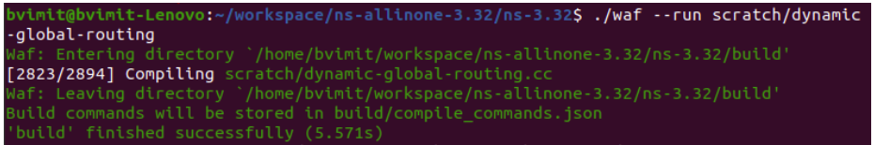

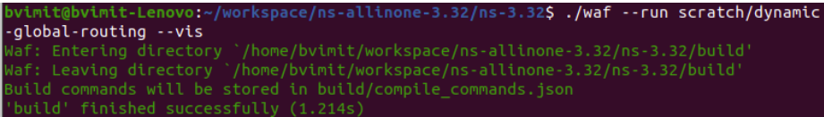

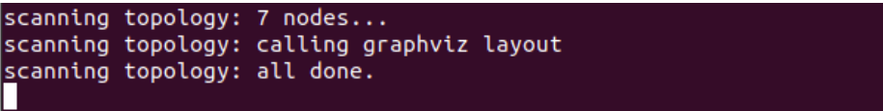

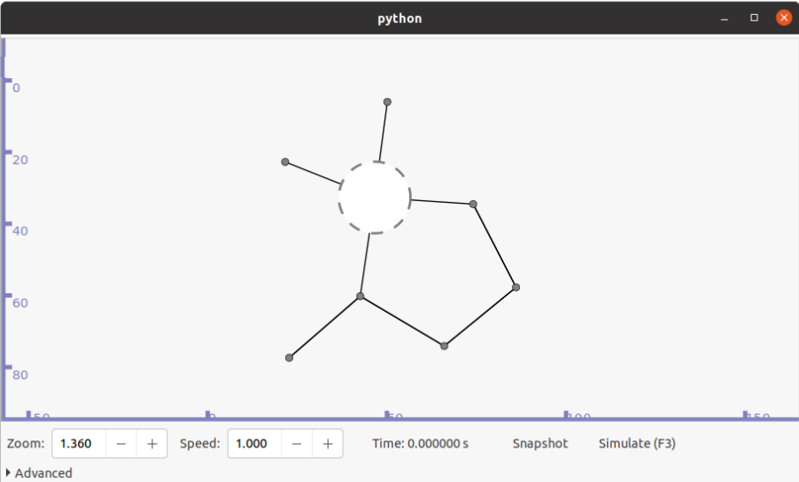

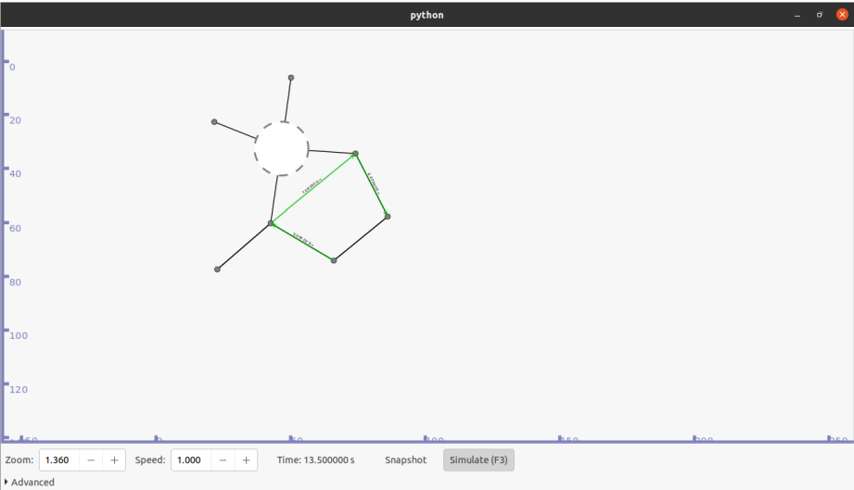

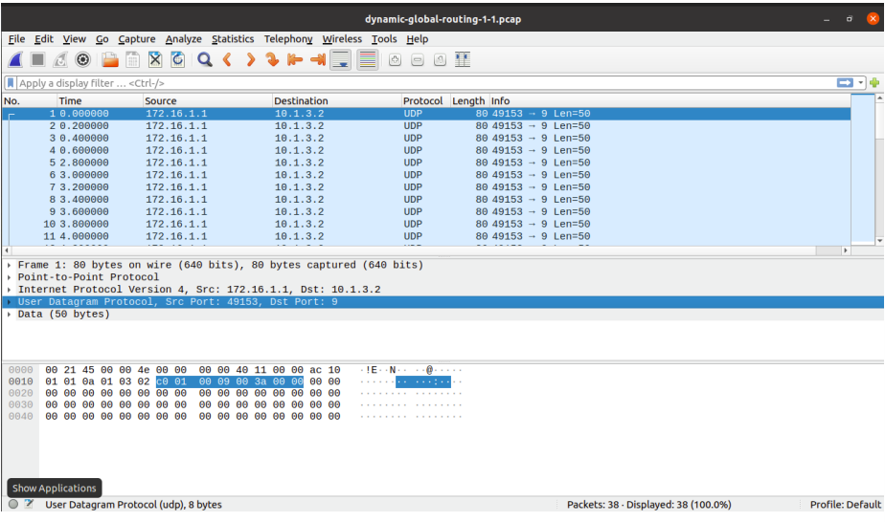

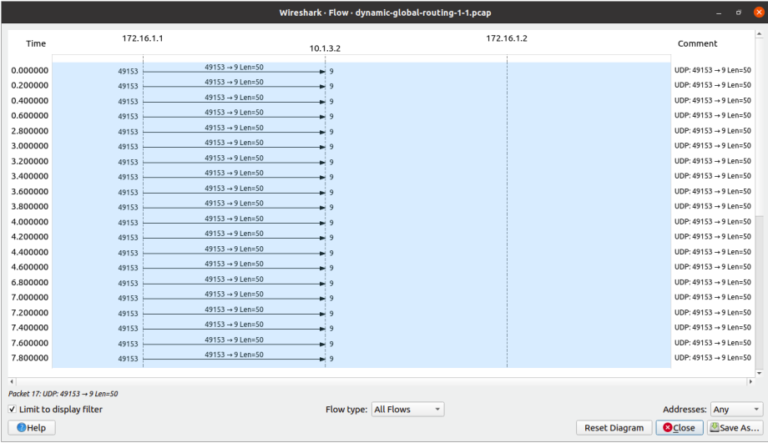

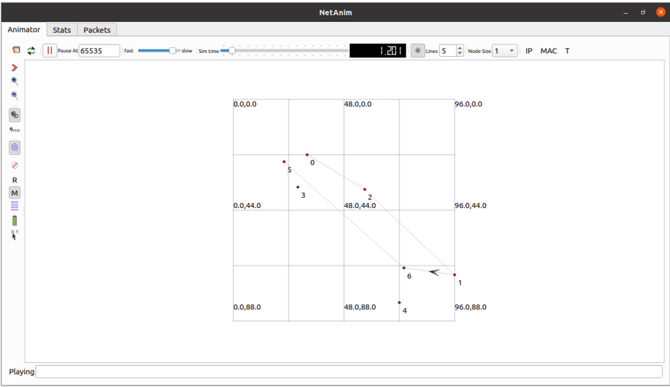

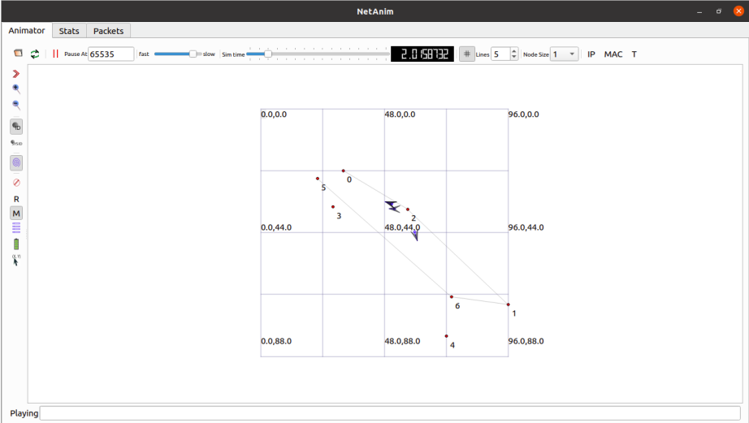

**Conclusion:**

In summary, dynamic global routing is essential for effectively controlling network traffic across connected networks. The global network infrastructure's goals are to maximise resource utilisation, evenly distribute traffic, improve fault tolerance and resilience, make it easier to scale, and assure security and privacy.

Dynamic routing protocols help with effective resource allocation, reducing congestion, and maximising network performance by dynamically choosing the best pathways for data packets. Capabilities for load balancing ensure an even distribution of traffic across available channels and assist prevent bottlenecks. Additionally, the capacity to recognise and reroute traffic during network outages improves the network's resilience and ensures ongoing connectivity.